**1.**  

**A.** I CAN PLAY TENNIS BUT I CAN'T PLAY FOOTBALL

**B.** I CAN'T PLAY TENNIS BUT I CAN'T PLAY FOOTBALL

**C**. I CAN'T PLAY TENNIS BUT I CAN PLAY FOOTBALL

**D.** I CAN PLAY TENNIS BUT I CAN PLAY FOOTBALL

**2.**

**CAN A DOLPHIN FLY?**

**A.** YES, IT CAN  **B.** YES, IT IS **C.** NO, IT ISN'T  **D.** NO, IT CAN'T

**3.**  

**A.** I CAN SWIM **B.** I CAN JUMP **C.** I CAN'T SWIM **D.** I CAN PLAY BASKETBALL

**4.** 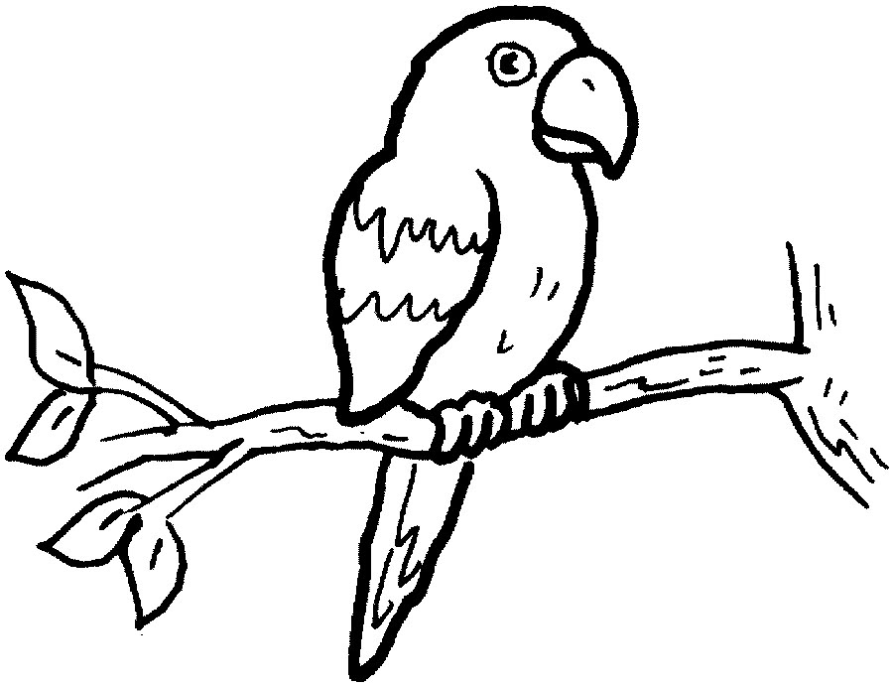 

**A.** A PARROT CAN'T FLY **B.** A PARROT CAN RIDE A BIKE

**C.** I PARROT CAN FLY **D.** A PARROT CAN FLYING

**5**. 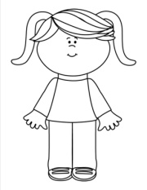 

**A.** THIS IS THEIR CAMERA **B.** THIS IS SHE CAMERA **C.** THIS IS HER CAMERA **D.** THIS IS YOU CAMERA

**6.** 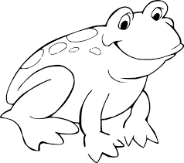 

**A.** A FROG CAN PLAY BASKETBALL **B.** A FROG CAN JUMP

**C.** A FROG CAN RIDE A HORSE **D.** A FROG CAN'T JUMPING

**7.** 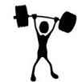 

**A.** I CAN LIFT WEIGHT BUT I CAN'T SING **B.** I CAN LIFT WEIGHT BUT I CAN SING

**C.** I CAN COLLECT COINS BUT I CAN'T SWIM **D.** I CAN'T LIFT WEIGHT BUT I CAN'T JUMP

**8**.  

A. I CAN RIDE A BIKE B. I CAN DANCE

C. I CAN'T RIDE A BIKE D. I CAN PLAY BASKETBALL

**9.** **MARY: CAN YOU DANCE?**

**TOM: *YES* , .......................**

**A.** I AM **B.** I CAN **C**. I CAN'T **D.** I DO

**10.** 

**A.** I CAN PLAY BASKETBALL **B.** I CAN JUMP

**C.** I CAN SWIM **D.** I CAN PLAY TENNIS