**................... İLKOKULU 2020-2021 EĞİTİM-ÖĞRETİM YILI İNGİLİZCE DERSİ 4.SINILAR 1.DÖNEM 1.YAZILI SINAV SORULARI**

**NAME-SURNAME:**

**NUMBER:**

**A)**Resimlerinaltınasınıfeşyalarınıningilizcesiniyazalım.(10x3=30Puan)

*notebook –pencil – book – eraser –pencilcase – schoolbag – ruler – door – Scissors – Sharpener*

|  |  |  |  |  |
| --- | --- | --- | --- | --- |
|  |  |  |  |  |
| .................................... | .................................... | .................................... | ................................... | .................................... |
|  |  |  |  |  |
|  |  |  |  | Açıklama: makas ile ilgili görsel sonucu |
| .................................... | .................................... | .................................... | .................................... | .................................... |

**B)** Boşluklara uygun ifadeleri yazınız. (5x2=10 Puan)

**Be quiet. Open thewindow. Sit down. Close thedoor. Cleanthe board.**

**\***

**\***

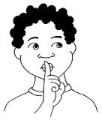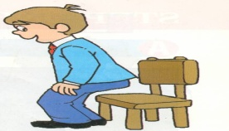**[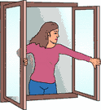](http://www.egitimhane.com)**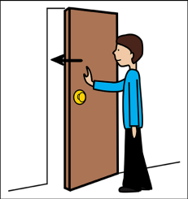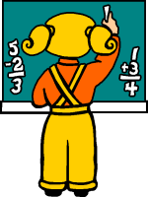

**……………..………… ……………….………. ………………………… ……………..…………. …………..……………**

**C)**Aşağıdakiboşluklarasayılarıningilizcesiniyazınız.(7X2=14Puan)

Thirty

Twenty-five



Seventeen

Eleven

…………..…………….….. …………………………….. ……….……………………..

Eight

Twenty

Two

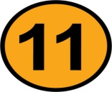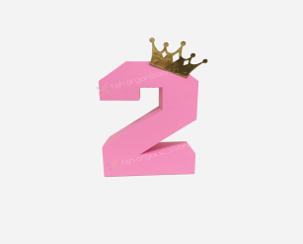

**……………………………….….………… ….…………………… ………………………**

**D)**Aşağıdaki İngilizce verilmiş rica cümlelerinin Türkçesini yazınız. (5X2=10Puan)

|  |  |
| --- | --- |
| 1. May I come in? 2. May I speak ? 3. May I taketheruler? 4. May I stay in theclassroom? 5. May I cleanthe board? | 1_______________________________  2_________________________________  3_________________________________ 4_________________________________  5_________________________________ |

**E)**Aşağıdakiboşluklarıtamamlayınız.(4x3=12Puan)

Japan

USA

Britain

Turkey



I am from .................... I am from ............. I am from .................. I am from ....................

**F)** AşağıdakikelimelerinTürkçeler' iniyazınız. (6x2=12 Puan)

window

Door

good morning

Be quiet

pencil

Book

**G)**Aşağıdakisorularıcevaplayınız.(4x3=12 Puan)

**East – South – North - West**

[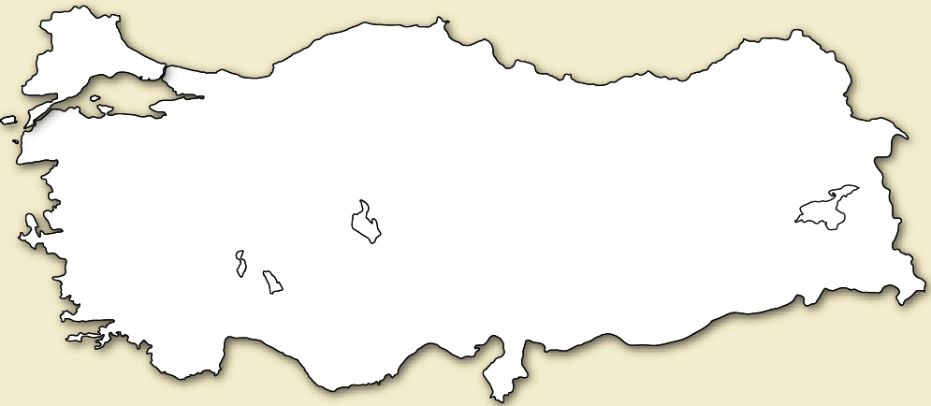](http://www.egitimhane.com)

**Zonguldak**

**Ağrı**

**Manisa**

**Adana**

a) Where is Sinop? Zonguldak is in the....……………………………..…

b) Where is İzmir? ……………………………………………..………………………

c) Where is Ağrı? ……………………………………………………………………..

b) Where is Adana? ………………………………………………….……………….…

**GOOD LUCK ☺**