



Name:...............................

Surname:..........................

Classroom:........................

Number:............................

1 – New Friends



3 – My Family

2 – My Classroom

4 – My Clothes

5 – Body Parts

6 – Home Sweet Home

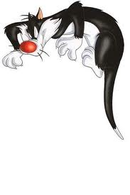

*Jackson*: .............................................

*Marta*: ................................... ........... *Jackson*: .............................................

*Marta*: ................................................ .............................................................

*Jackson*: ................................................ ..............................................................*Marta*: ................................................

*Jackson*: ..............................................

*Marta*: .................................................

*Jackson*: ................................................ ..............................................................*Marta*: .................................................

*Yan taraftaki Marta ve Jackson arasında geçen konuşmayı Türkçeye çevirip aşağıya yerlerine yazınız.*

1 – New Friends

***Sample Dialogue ( Örnek Diyalog )***

*Jackson*: Good morning!

*Marta*: Good morning!

*Jackson*: Hello ! What is your name ?

*Marta*: Hi ! My name is Marta. What is your name ?

*Jackson*: My name is Jackson. How are you ?

*Marta*: Fine thanks, and you ?

*Jackson*: Thank you. I am fine.

*Marta*: Nice to meet you !

*Jackson*: Nice to meet you, too ! Good bye!

*Marta*: Good bye !



**Exercise**

**2**

*Aşağıda karışık olarak verilmiş sözcük dizelerini doğru sıraya koyunuz.*

Aşağıdaki kutucuktaki diyalog için ayrılmış yerleri, ailenizin bir üyesiyle İngilizce olarak doldurunuz.

( Yukarıdaki diyaloglardan örnek alabilirsiniz. Ancak alıştırmamızın yararlı olması için yukarıdan bakarak yazmamaya dikkat ediniz. )

1 – is / name / what / your ?

...............................................................

2 – name / my / Zuzu / is .

...............................................................

3 – are / you / how ?

...............................................................

4 – and / fine / you / thanks / I am ?

...............................................................

5 – you / nice / meet / you

...............................................................

: .............................................

: ................................... ........... *.* : .............................................

: ............................................... .............................................................

: ............................................... .............................................................. *.* : ..............................................

: ..............................................

: ...............................................

: ............................................... .............................................................. *. :* ................................................

*................................................................................................ ..*

*Hello! My name is Ben 10! What is your name ?*

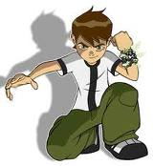

**Yandaki kutucuğa sevdiğiniz bir çizgi film kahramanının resmini çiziniz ve konuşma baloncuğunu doldurunuz.**

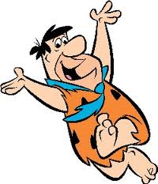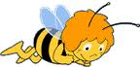

*His name is Fred Flintstones.*

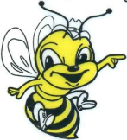

What is his name?

Onun adı ne ?

**Aşağıdaki kutucuklardaki sorulara cevaplarını, cevapları verilmiş olanlaraysa sorularını yazınız.**

*Her name is Wilma Flintstones.*

What is her name?

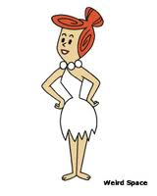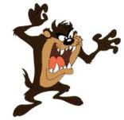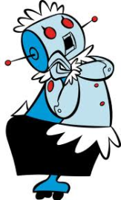

A : What is his name ?

B : ..............................................

A : What is his name ?

B: ................................................

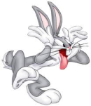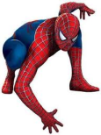

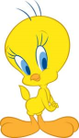

A : What is her name ?

B : ..................................................

A : What is his name ?

B: .................................................



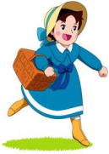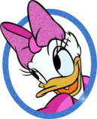

A : What is her name ?

B: .................................................

A : What is her name ?

B: .................................................

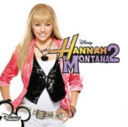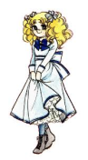

A : .................................................

B: Her name is Candy.

A : .................................................

B: Her name is Hannah Montana.

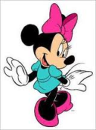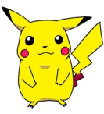

A : .................................................

B: Her name is Minnie Mouse.

A : .................................................

B: Her name is Pikachu .

A : .................................................

B: His name is Caillou.

A : .................................................

B: His name is Garfield.

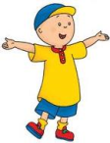

2 – My Classroom

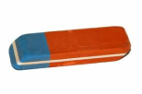

***Aşağıdaki sınıf nesnelerinin altlarına İngilizce anlamlarını yazınız.***

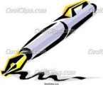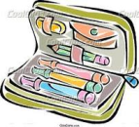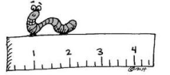

...................

...................

...................

...................

...................

...................

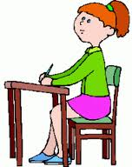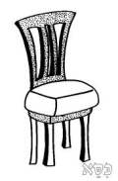

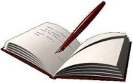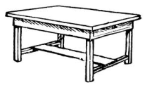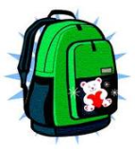

...................

...................

...................

...................

...................

...................

***What is this ? ( Bu nedir ? )***

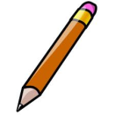

***A: What is this ?***

***B: It is a pencil.***

A: What is this ?

B: ........................

A: What is this ?

B: ...........................

***Aşağıdaki soruları cevaplarken nesnelerin İngilizcelerini sözlükten bulmayı unutmayın!***

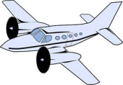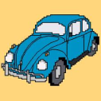

A: What is this ?

B: ........................

A: What is this ?

B: ........................

A: What is this ?

B: ........................

A: What is this ?

B: ........................

A: What is this ?

B: ........................

A: What is this ?

B: ........................

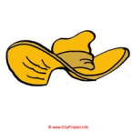

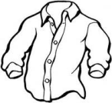

***A: Is this a ruler ?***

***B: Yes, it is.***

A: Is this a shirt ?

B: ..............................

***A: Is this a pen ?***

***B: No, it isn’t.***

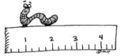

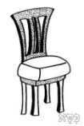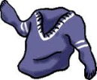

A: Is this a table ?

B: .................................

A: Is this a jacket ?

B: ............................

A: Is this a hat?

B: ................................



A: Is this a car ?

B: ............................

A: Is this a bag?

B: ................................

A: Is this a pencil ?

B: .................................

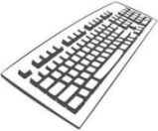

***A: What is that ?***

***B: It is a keyboard.***

A: Is thata book ?

B: .................................

A: Is thata dog ?

B: ............................

A: Is thata cow?

B: ................................

A: Is thata cat ?

B: ..............................

***A: Is that a pen ?***

***B: No, it isn’t.***

***A: Is that a ruler ?***

***B: Yes, it is.***

Aşağıdaki soruları cevaplarken nesnelerin İngilizcelerini sözlükten bulmayı unutmayın!

A: What is that?

B: ........................

A: What is that?

B: ........................

A: What is that?

B: ........................

A: What is that?

B: ........................

A: What is that?

B: ........................

A: What is that?

B: ........................

A: What is that ?

B: ...........................

A: What is that ?

B: ........................

***What is that ? ( Şu nedir ? )***

A: Is thatan apple ?

B: .................................

A: Is thata fly ?

B: ............................

A: Is thatan apple ?

B: ................................

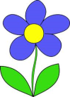

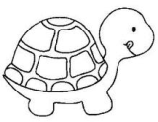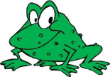

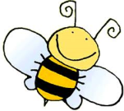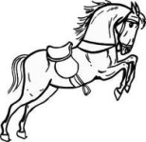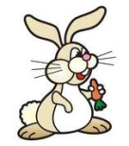

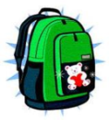

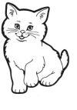

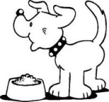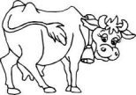

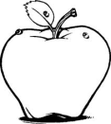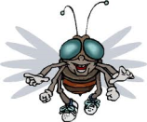

***What are those ? ( Şunlar nedir ? )***

***What are these ? ( Bunlar nedir ? )***

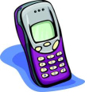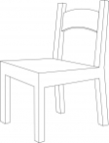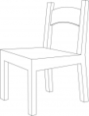

***A: What are those?***

***B: They are mobile phones.***

***A: What are these?***

***B: They are chairs.***

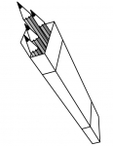

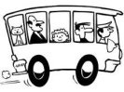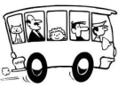

***A: What are those?***

***B:*** ............................................

***A: What are these?***

***B:*** ............................................

***A: What are those?***

***B:*** ............................................

***A: What are these?***

***B:*** ............................................

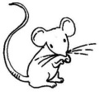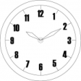

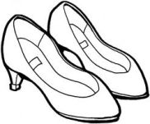

***A: What are those?***

***B:*** ............................................

***A: What are these?***

***B:*** ............................................



3 – My Family

***Aşağıdaki sayıların İngilizcelerini yazınız.***

..................

..................

..................

..................

..................

***1***

***3***

***5***

***7***

***9***

***10***

***8***

***6***

***4***

***2***

..................

..................

..................

..................

..................

***Aşağıdaki kutucuktaki yazıyı Türkçeye çevirip yandaki kutuya yazınız.***

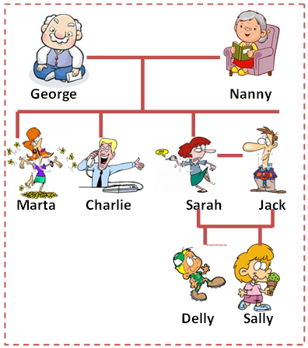

....................................................

....................................................

....................................................

....................................................

....................................................

....................................................

....................................................

....................................................

....................................................

....................................................

....................................................

....................................................

....................................................

....................................................

....................................................

Hello ! My name is Sally. This is my family. I have got a grandfather. His name is George. I have got a grandmother. Her name is Nanny. I have got an aunt. Her name is Marta. I have got an uncle. His name is Charlie. I have got a mother. Her name is Sarah. I have got a father. His name is Jack. I have got a brother. His name is Delly.

***Aşağıdaki kutucuğa bir aileniznz resmini çiziniz ve hangi aile üyelerine sahip olduğunuzu anlatınız.***

Hello ! My name is ............... . This is my family. I have got ................. .... ................ ..................................... ........................... ........ .....................................................................................................................................................................................................................................................................................................................................................................................................................................................................................................................................................................................................................................................................................................................................................................................................................................................................................................

Yanda tablodaki kelimeleri kullanarak, aşağıdaki numaralanmış aile üyelerinin kimler olduğunu baloncuklara yazınız.

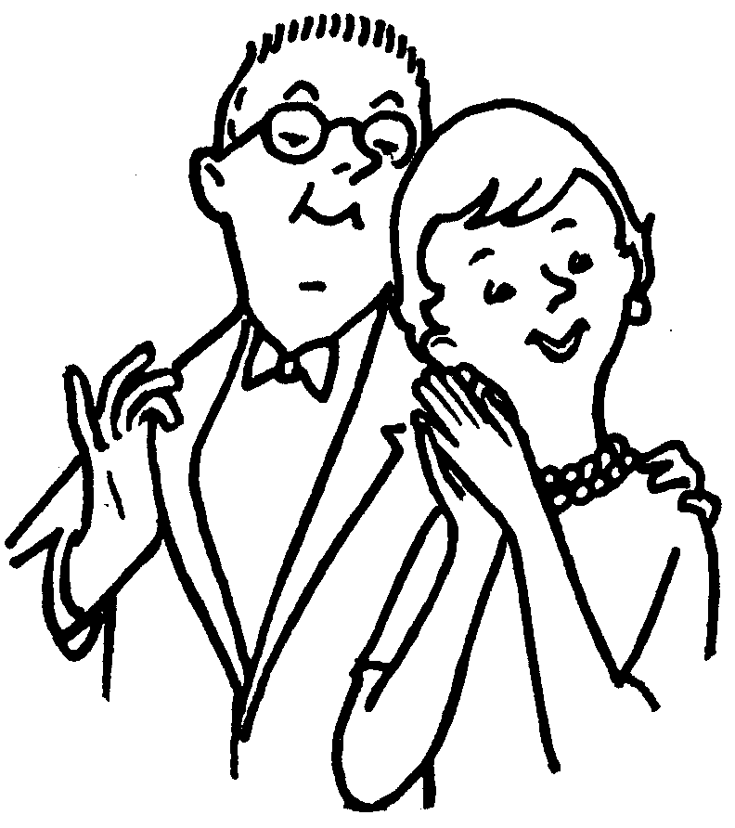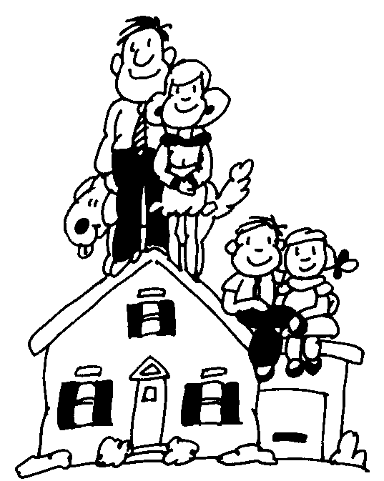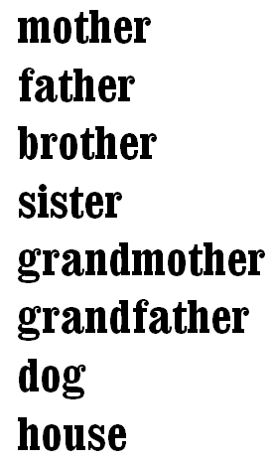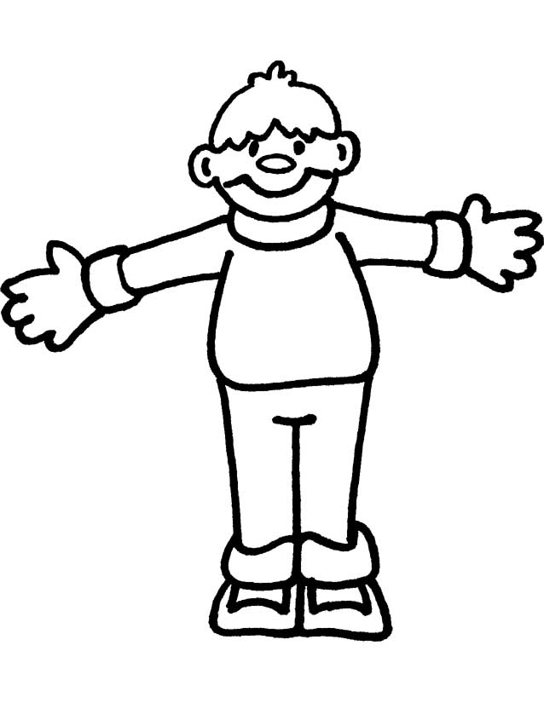

**1. This is my** \_\_\_\_\_\_\_\_

**6. This is my** \_\_\_\_\_\_\_

**5. This is my**

\_\_\_\_\_\_\_\_\_\_\_\_\_\_\_\_\_\_\_

**4. This is my** \_\_\_\_\_\_\_\_

**3. This is my** \_\_\_\_\_\_\_

**2. This is my** \_\_\_\_\_\_

**7. This is my** \_\_\_\_\_\_

**8. This is my** \_\_\_\_\_\_\_

**Numaralara göre yandak**

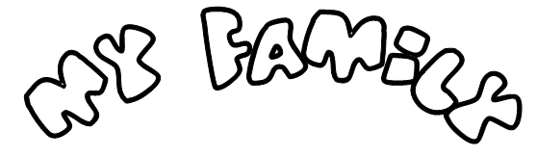

4 – My Clothes

***Aşağıdaki şekilleri altlarında yazılı olan renkler ile boyayınız.***

Purple

Green

Blue

Yellow

Red

White

Grey

Orange

Pink

Red

Brown

***Aşağıdaki kıyafetlerin altlarına İngilizcelerini yazınız.***

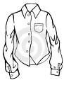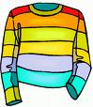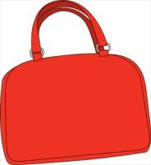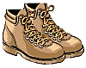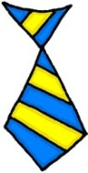

.......................

.......................

.......................

.......................

.......................

.......................

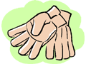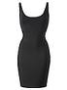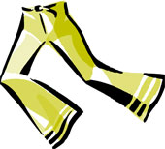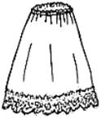

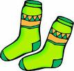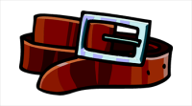

.......................

.......................

.......................

.......................

.......................

.......................

***Aşağıdaki boş kutucuğa bir resminizi yapıştırınız ve hangi kıyafetlere sahip olduğunuzu renklerini de belirterek yazınız.***

Hello ! My name is .......................

I have got ...........................................................................

.............................................................................................

.............................................................................................

.............................................................................................

.............................................................................................

.............................................................................................

.............................................................................................

***Aşağıdaki boş kutucuklara yanlarındaki resimlerde kız ve erkeklerin hangi kıyafetlere sahip olduklarını renkleri ile birlikte yazınız. ( Renkler siyah beyaz olduğundan görünmediği için renkleri kendiniz seçiniz) Sözlük kullanmayı unutmayınız.***



*She has got a pink scarf.*

*She has got a brown jacket.*

*She has got orange trousers.*

*She has blue shoes.*

*He has got a brown and blue scarf.*

*He has got a grey sweater.*

*He has got brown trousers.*

*He has got brown shoes.*



*.......................................................................................................................................................................................................................................................................................................................................................................................................*

*.......................................................................................................................................................................................................................................................................................................................................................................................................*

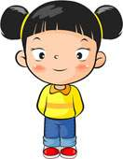

*.......................................................................................................................................................................................................................................................................................................................................................................................................*

*.......................................................................................................................................................................................................................................................................................................................................................................................................*

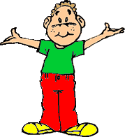

*.......................................................................................................................................................................................................................................................................................................................................................................................................*

*.......................................................................................................................................................................................................................................................................................................................................................................................................*

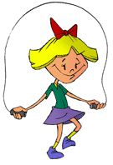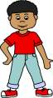

*.......................................................................................................................................................................................................................................................................................................................................................................................................*

*.......................................................................................................................................................................................................................................................................................................................................................................................................*

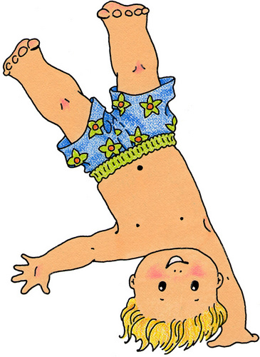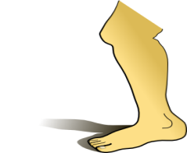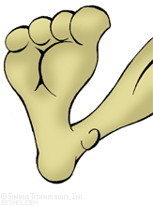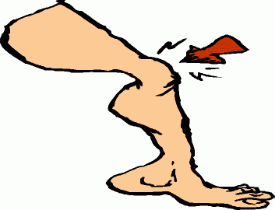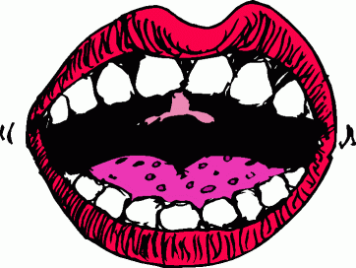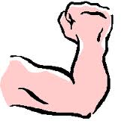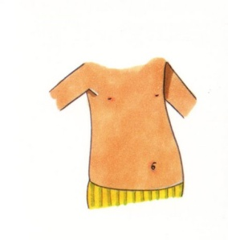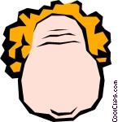G:\IMAGES\body\EAR\1194986541442028018ear_-_body_part_nicu_buc_01.svg.thumb[1].png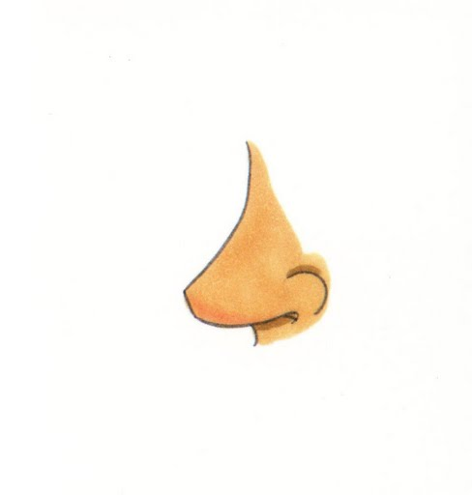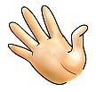

***Aşağıdaki vücut parçalarının İngilizcelerini sözlükten bularak altlarına yazınız.***

5 – Body Parts

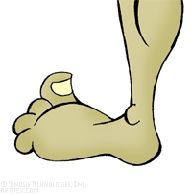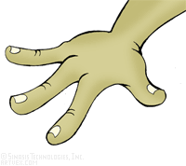

www.eslprintables.com

***Long = Uzun***

***Big= Büyük***

***Small=Küçük***

***Short=Kısa***

***Aşağıdaki yaratıkların fiziksel özelliklerini örnekteki gibi yazınız.***

...........................................

...........................................

...........................................

...........................................

...........................................

...........................................

...........................................

**It has got two big eyes.**

**It has got short hair.**

**It has got two long ears.**

**It has got two short arm**

**It has got short legs.**

**It has got small feet.**

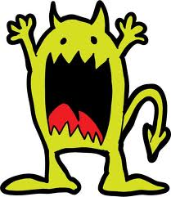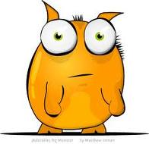

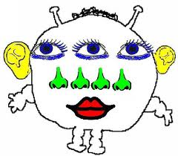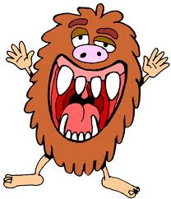

...........................................

...........................................

...........................................

...........................................

...........................................

...........................................

...........................................

...........................................

...........................................

...........................................

...........................................

...........................................

...........................................

...........................................

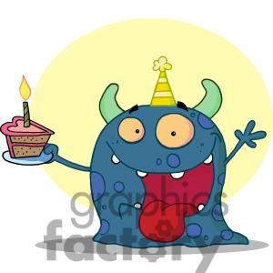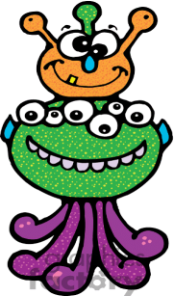

...........................................

...........................................

...........................................

...........................................

...........................................

...........................................

...........................................

...........................................

...........................................

...........................................

...........................................

...........................................

...........................................

...........................................

**Aşağıdaki açıklamaları okuyunuz ve yanlarındaki boşluklara özellikleri anlatılan yaratıkları çiziniz ve renklendiriniz.**

It has got a big head.

It has got long hair.

It has got one big eye.

It has got one small nose.

It has got four ears.

It has got six arms.

It has got one leg.

It is orange.

It has got three big eyes.

It has got a long nose.

It has got four very long ears.

It has got big teeth.

It has got one nig arm.

It has got short legs

It has got big feet.

It is purple.

It has got a big head.

It has got very long hair.

It has got six small eyes.

It has got a long nose.

It has got six small ears.

It has got very big hands.

Ih has got four long legs.

It has got four small feet.

It is red.

It has got two heads.

It has got short hair.

It has got three eyes.

It has got two noses.

It has got two small ears.

It has got eight short arms.

It has got two short legs.

It has got two big feet.

It is green.

6 – Home Sweet Home

Aşağıdaki nesnelerin İngilizcelerini yazınız.

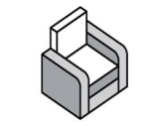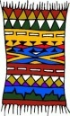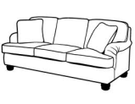

**Roof**

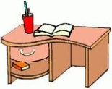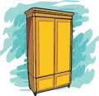

**Bedroom**

**Living Room**

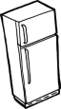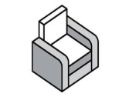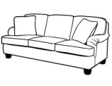

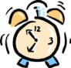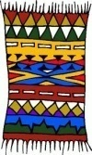

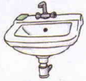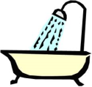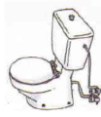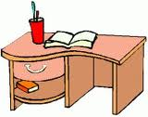

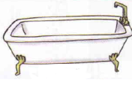



**Bathroom**

**Kitchen**

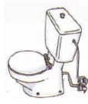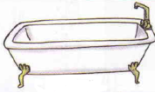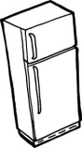

***Examples ( Örnekler )***



***A: Where is the sofa ?***

***B: It is in the living room.***

***A: Where is the bed ?***

***B: It is in the bedroom.***

***Aşağıdaki soruları yukarıdaki örnekteki gibi cevaplayınız.***

***Eşyaların evin hangi odasında olduğunu belirten aşağıdaki cümleleri okuyunuz ve eğer doğru ise yanına ‘’ True’’ , eğer yanlış ise yanına ‘’False’’ yazınız.***

A: Where is the carpet ?

B: ......................................

A: Where is the arm chair ?

B: .........................................

A: Where is the wardrobe ?

B: .........................................

A: Where is the TV ?

B: .........................................

***The sofa is in the living room*. ( Kanepe oturma odasındadır)**

1. The Table is in the bathroom. ( ............... )
2. The Sofa is in the living room. ( ............... )
3. The Clock is in the kitchen ? ( ............... )
4. The lamb is in the kitchen ? ( ............... )
5. The cooker is in the bedroom. ( ...............)
6. The desk is in the bathroom. ( ............... )
7. The carpet is in the living room. ( ............ )
8. The armchair is in the living room. ( ........ )
9. The fridge is in the kitchen. ( ............... )
10. The bathtub is in the bathroom. ( ........... )

A: Where is the lamb ?

B: .........................................

A: Where is the desk ?

*B: .........................................*

A: Where is the fridge ?

B: .........................................

A: Where is the bed ?

B: .........................................

A: Where is the table ?

B: .........................................

A: Where is the clock ?

B: .........................................

A: Where is the washbasin ?

B: ..........................................

A: Where is the toilet ?

B: I.........................................

A: Where is the bathtube ?

B: .........................................

A: Where is the shower ?

B: .........................................

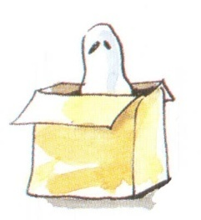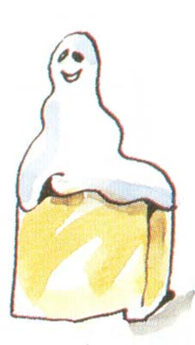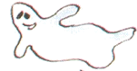

***Where is the ghost ? ( Hayalet nerede ? )***

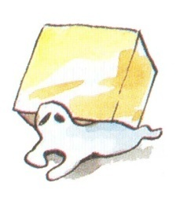

The ghost is under the box.

The ghost is in the box.

The ghost is on the box.

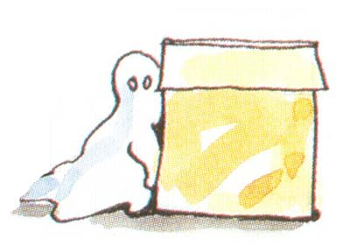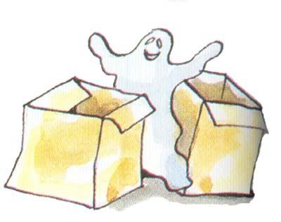

The ghost is next to the box.

The ghost is between the boxes.

***Yandaki oda resmindeki eşyaların yerlerini ‘’ in, on , under, between ve next to ‘’ kullanarak belirtiniz.***

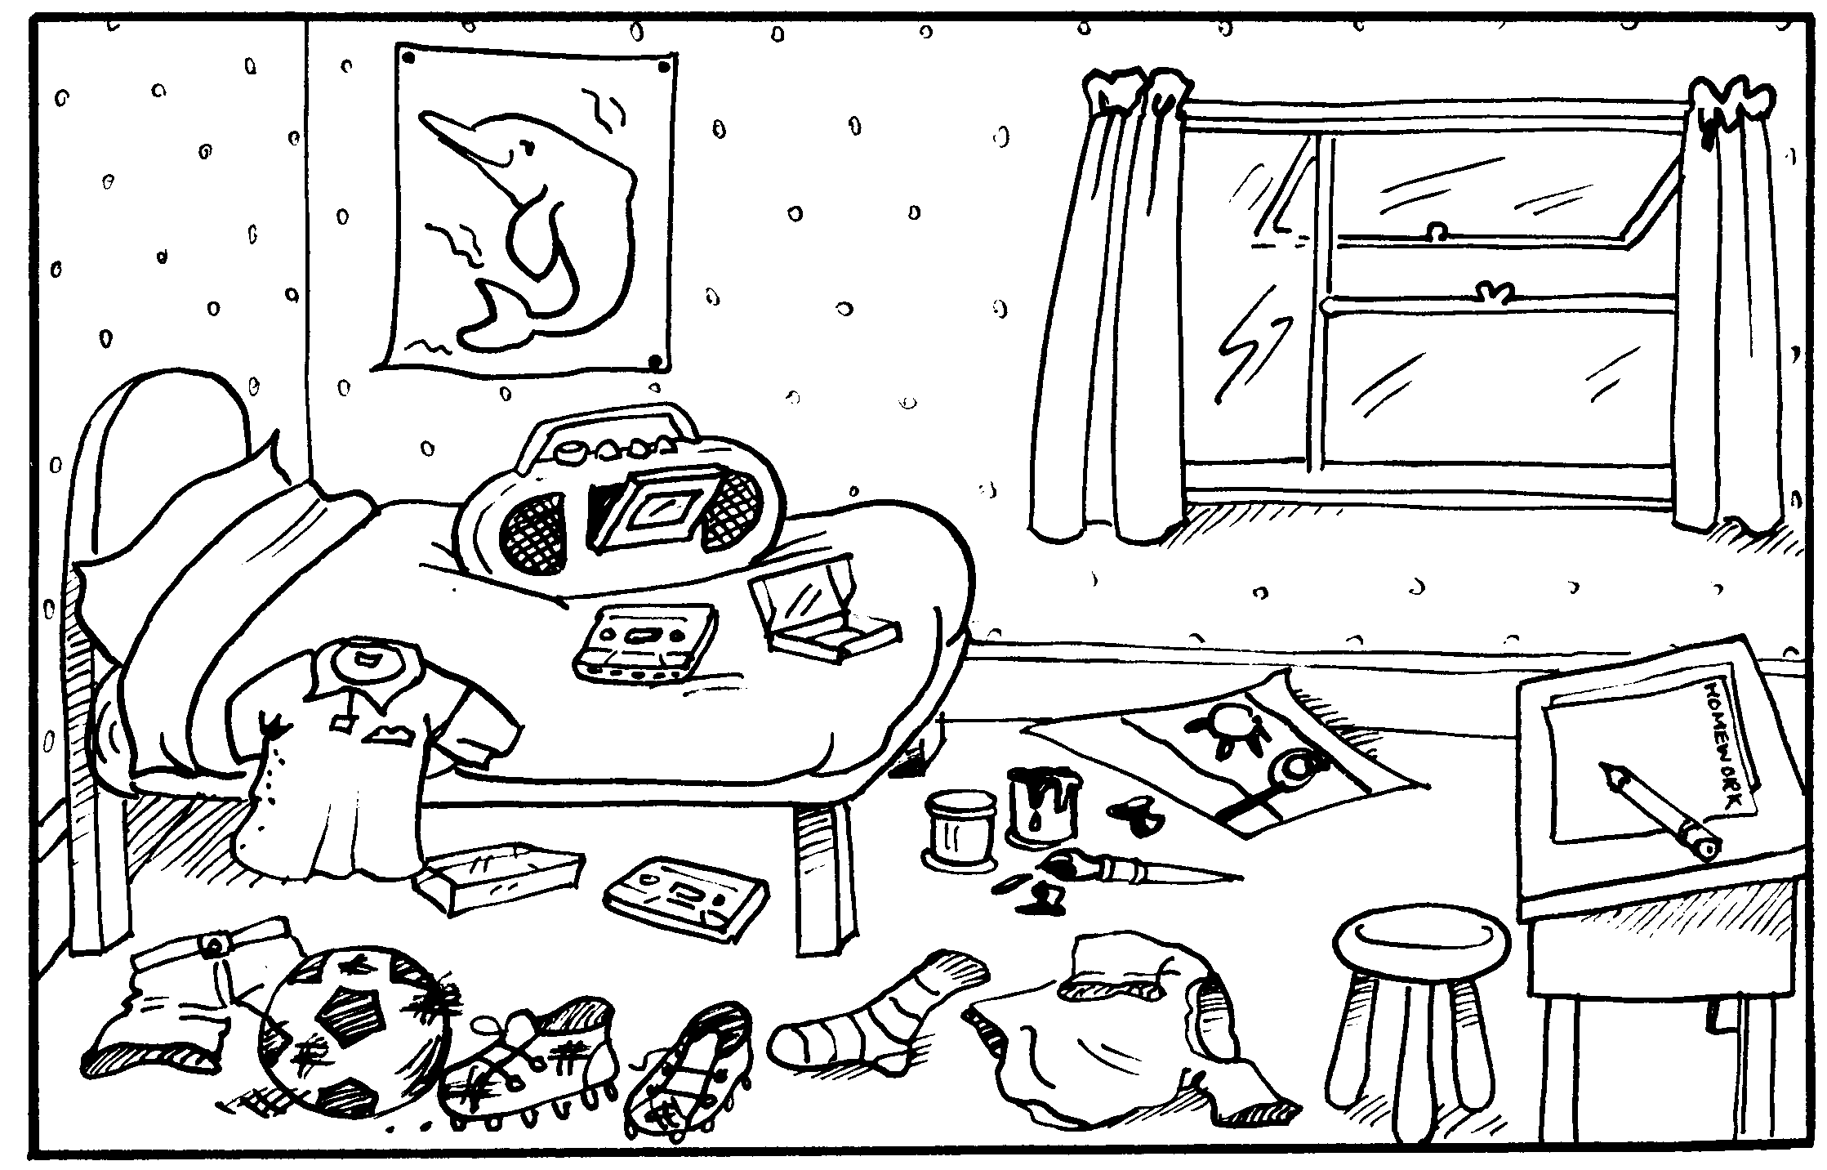

The ball is between shoes and trousers.

...........................................................................................

...........................................................................................

...........................................................................................

...........................................................................................

...........................................................................................

...........................................................................................

...........................................................................................

...........................................................................................

...........................................................................................

...........................................................................................

...........................................................................................

...........................................................................................

...........................................................................................

...........................................................................................

***Yandaki odada hangi nesnelerin bulunduğunu yazınız.***

There is a bed in the room.

There are six books in the room.

...........................................................................................

...........................................................................................

...........................................................................................

...........................................................................................

...........................................................................................

...........................................................................................

...........................................................................................

...........................................................................................

...........................................................................................

...........................................................................................

...........................................................................................

...........................................................................................

...........................................................................................

