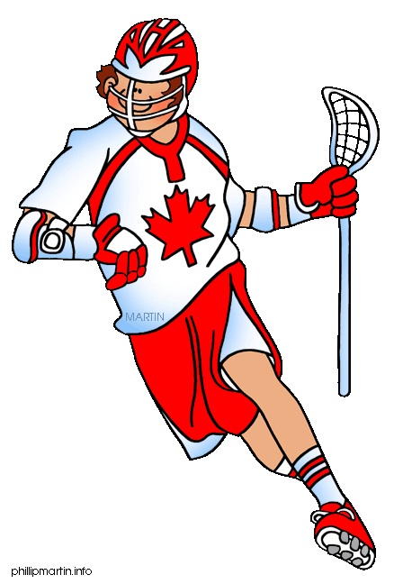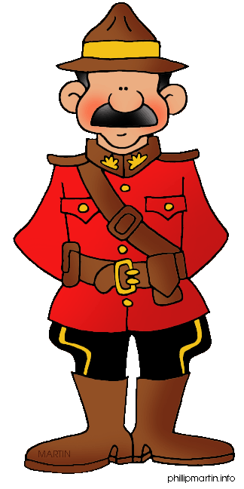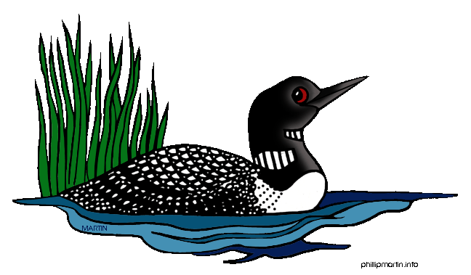Write three words in each category! Name: _______________ Score:_______

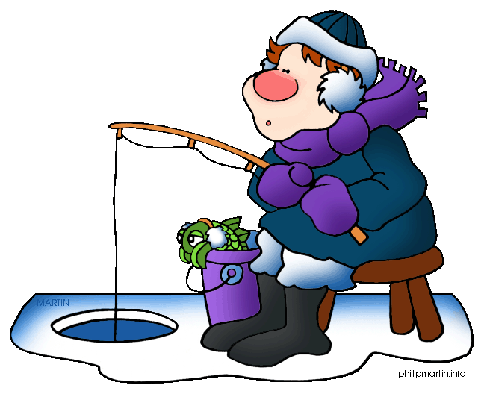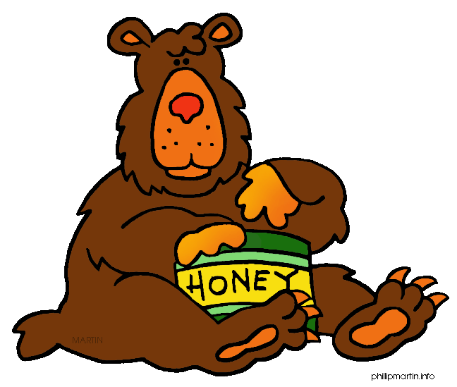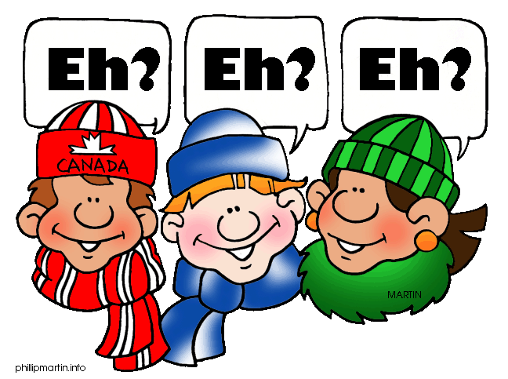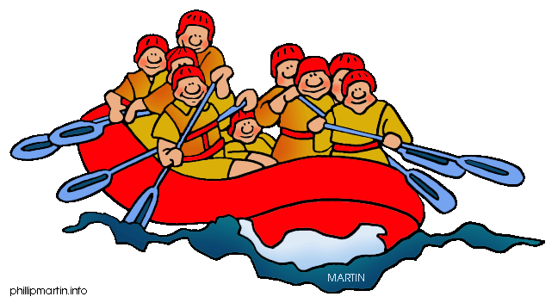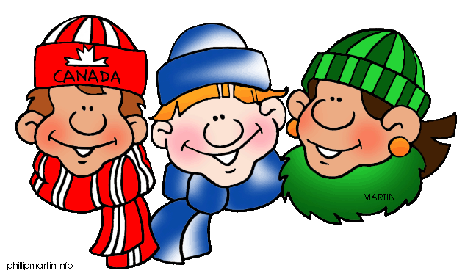

Canadian words

Musicians

Provinces

Canadian sports

Famous Canadian actors

Bordering seas

Things related to Canada

Canadian Olympic Host Cities

Athletes

Newspapers

Canadian food

Landmarks in Canada

Canadian coins

Cities

Native tribes