Write three words in each category! Name: _______________ Score:_______

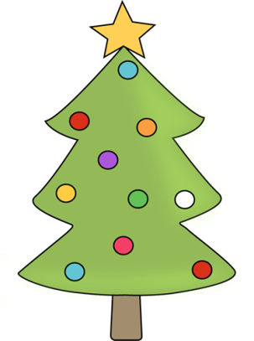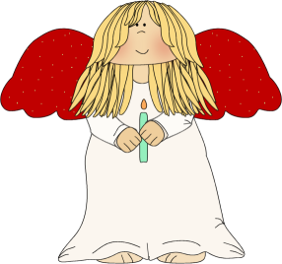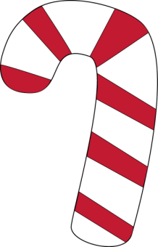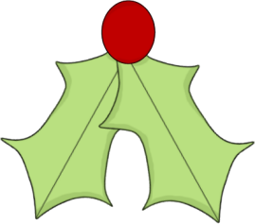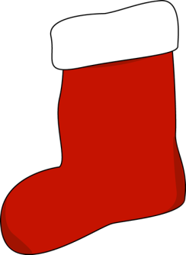

Three Christmas drinks

Three green Christmas decorations

Three of Santa’s reindeer

Three Christmas days

Three things on **your** christmas table

Three Christmas figures

Three Christmas presents

Three Christmas superstitions

Three things you eat at Christmas

Three Christmas movies

Three Christmas Carols

Three Christmas decorations

Three traditions at Christmas