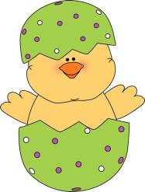Write three words in each category! Name: _______________ Score:_______

Three Easter Days!

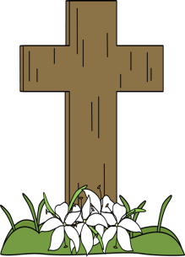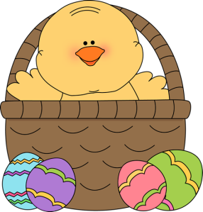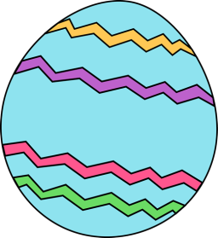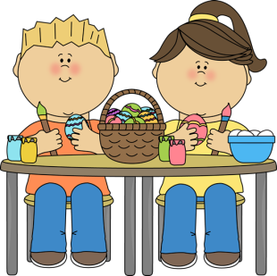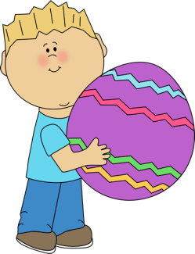

Three egg foods!

Three Easter decorations!

Three Easter foods!

EASTER in three other languages!

Three Easter symbols!

Three Easter games!

Three Easter characters

Three Easter traditions!

Three Easter animals!

Three Easter candies!

Three spring months!

Three Easter flowers!