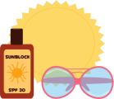Write three words in each category! Name: _______________ Score:_______

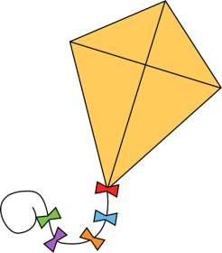

Things you will miss!

Traditions.

”Jobs” in your class.

Funny incidents!

Favourite activities!

Lunch favourites!

Outings this year!

New friends!

Hard things to learn!

Books you read!

Bad experiences!

Marks you received!

Good experiences!

Teachers you had!

Subjects you studied!