**A)KELİMELERİ TAMAMLAYALIM.**

Parrot

Parot

Parrout

Turtle

Turle

Turtrle

Fisch

Fish

Fişh

|  |
| --- |
| **R_d_ a h_rs_** |



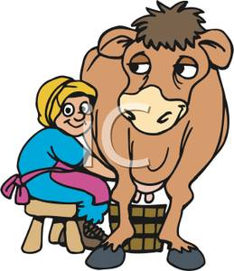

|  |
| --- |
| **M_lk a c_w** |

|  |  |  |
| --- | --- | --- |
| **animales,animales domésticos,caninos,mamíferos,mascotas,naturaleza,perro pastor de Shetland,perros,perros pastores escoceses,seres vivos** | **animales,aves,gallinas,naturaleza,pájaros,pollos** | **animales,caricaturas,dibujos animados,naturaleza,pájaros,pollitos,pollos** |
| **a. poodle**  **b. dog**  **c. hound** | **a. bird**  **b. cock**  **c. hen** | **a. duck**  **b. kitten**  **c. chicken** |
| **MH900345816** | **agricultura,animales,ganado vacuno,mamíferos,naturaleza,vacas** | **animales,caballos,mamíferos,naturaleza** |
| **a. rabit**  **b. rabbit**  **c. bug** | **a. veal**  **b. beef**  **c. cow** | **a. horse**  **b. louse**  **c. donkey** |
| **ver detalles** | **animales,animales de compañía,gatos,naturaleza** | **C:\Users\sb\AppData\Local\Microsoft\Windows\Temporary Internet Files\Content.IE5\K17J4NVH\MC900391432[1].wmf** |
| **a. sheet**  **b. sheep**  **c. ship** | **a. catt**  **b. cart**  **c. cat** | **a.fish**  **b.fısh**  **c.fişh** |



|  |
| --- |
| **W_t_r fl_w_rs** |



|  |
| --- |
| **F_ _d _n_m_ls** |

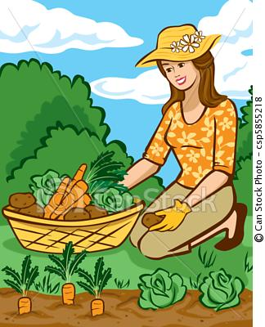

|  |
| --- |
| **Pl_nt v_g_t_bl_s** |

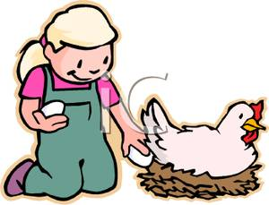

|  |
| --- |
| **C_ll_ct _ggs** |

**B)DOĞRU OLAN KELİMEYİ İŞARETLEYELİM.**

Börd

Bird

Bırd

Cat

Cet

Cad

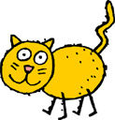

English Teacher

Gizem Şeyda KAYALI

Rabbitt

Rabit

Rabbit

Dog

Doog

Dogg