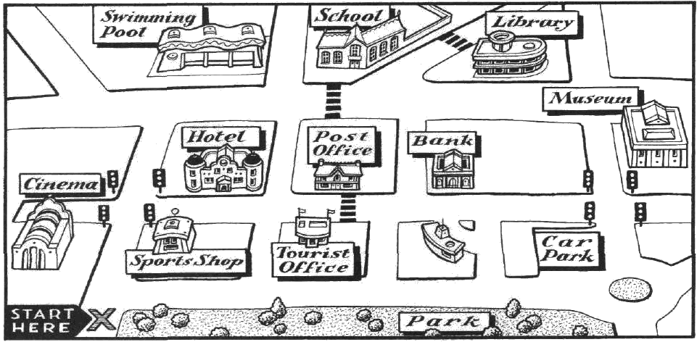
A. Look at the map. Read the directions and write the names of the places.
1. A: Where’s the swimming pool?
B: Go straight on. Cross the road. It’s opposite the hotel.
2. A: Where’s the ………………………………?
B: Turn right. It’s on the right.
3. A: Where’s the ………………………………?
B: Turn right. Take the first street on the left. Go straight on. It’s opposite the hotel.
4. A: Where’s the ……………………………..?
B: Go straight on. Take the third street on the right. Go straight on and it’s on the left, opposite the
post office.
B. Look at the map again. Complete the directions.
1. A: Where’s the sports shop?
B: Turn right. It’s on the left.
2. A: Where’s the hotel?
B: …………………… straight on. Take the second …………………………… on the right. It’s …………..…… the left.
3. A: Where’s the museum?
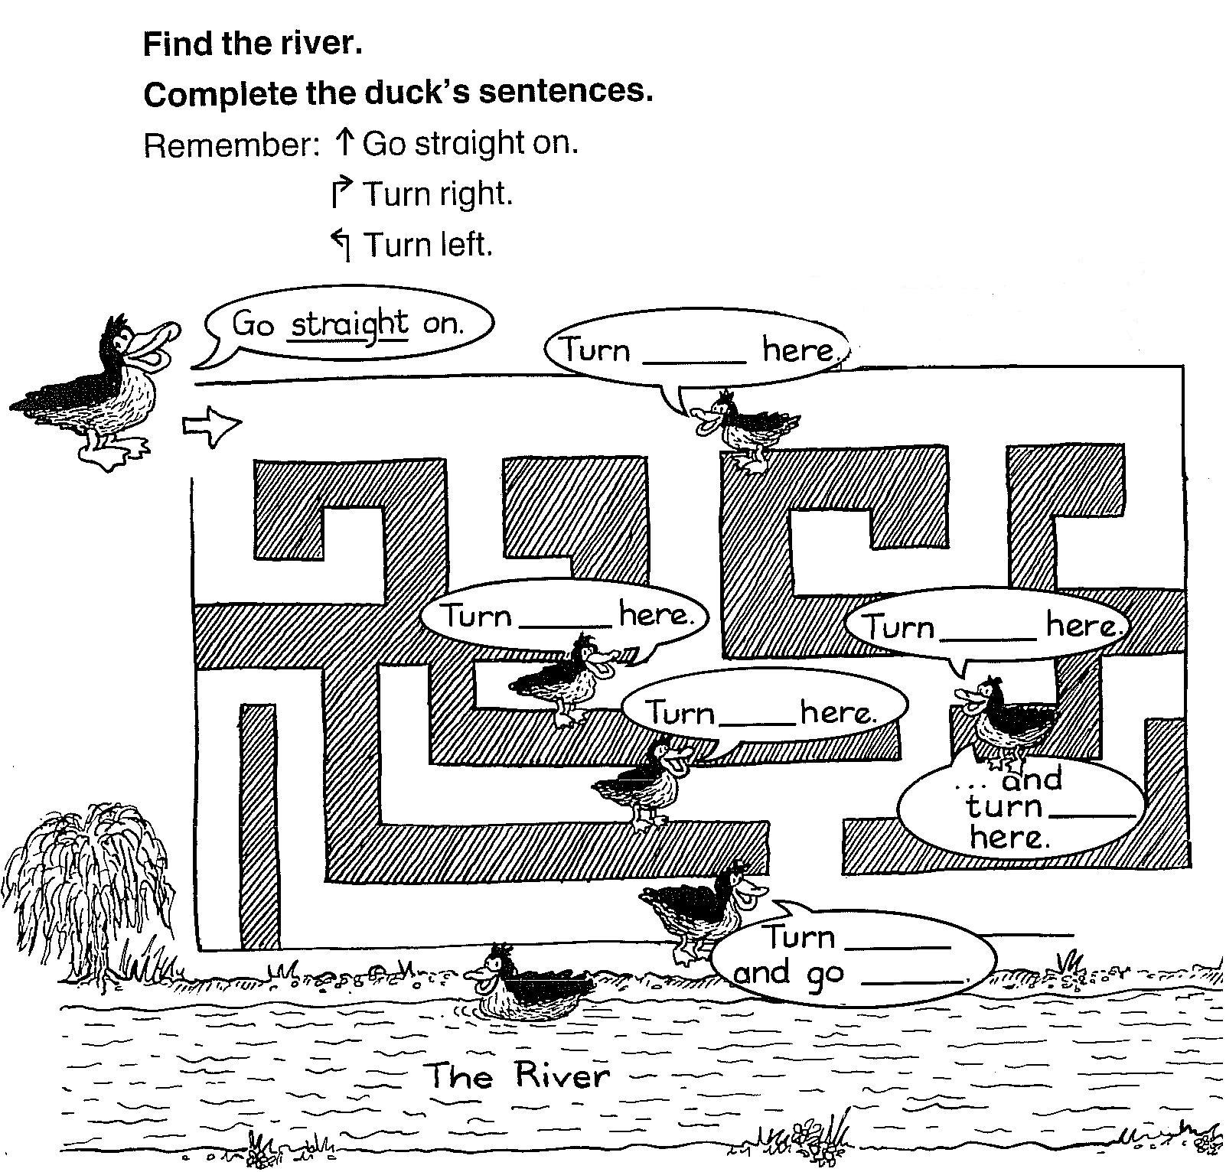
B: Turn right. Take the fourth street ………………. the left. Go …………………. on. It’s on the ……………………..



