ŞEHİT RECEP DEMİR SECONDARY SCHOOL
6. GRADES FIRST WRITTEN EXAM
NAME & SURNAME: …………………………………………. Number: .... MARK:

A. Saatleri yazın. What time is it? 10p
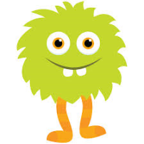
11:30= | 8:45= It's quarter to nine.
8:00= | 6:55=
2:15= | 9:20=
B. Öznelere bakarak doğru olan şıkkı yuvarlak içine alın ve cümleleri Türkçe'ye çevirin. 12p 1. Beril do / does her homework everyday. -->
2. I do / does my homework in the afternoons. -->
3. Ceren get up / gets up at 7:30. -->
4. Rüveyda have / has breakfast every morning.-->
5. She sleep/ sleeps at 10:00. -->
6. I brush / brushes my teeth at 8 o'clock. -->

C. Zaman ifadelerinin Türkçelerini yazın. 10p
1) In the morning: 5) After school: 9) Never:
2) Often: 6) Sometimes: 10) On Sunday:
3) Every morning: 7) On weekdays:
4) Everyday: 8) At the weekend:

D. Soru kelimelerinin Türkçelerini yazın. 6p
A) How often: B) Who: C) When:
D) Where: E) What time: F) Why:

E. Sorularla cevapları eşleştirin. 5p
1)What do you do after school? |  | A) Once a week
2)How often do you play soccer? |  | B) at 3:30
3)What time do you get home? |  | C) I go online
4)When do you attend English courses? |  | 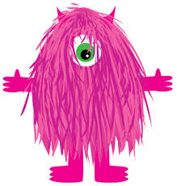  D) It's a small cake
5)What does 'muffin' mean? |  | E) On Wednesdays
1)_______________ five oranges | 2) _______________ a few eggs | 3) _______________ some milk
4) _______________ an orange | 5) _______________ a little butter | 6) _______________ two eggs
1) Ömer ____________ (go) to school at 8:10 | 5) He ________ (play) soccer after school
2) I ____________ (come) home at 3:30 | 6) She ____________ (like) cheese and olives
3) I _________ (watch ) TV in the evenings | 7) My mother never ____________ (read) newspaper
4) Şevval _________ (watch ) TV in the evenings | 8) You always ____________ ( eat ) bagels
F. There is veya There are ile doldurun. 6p
G) Cümleleri Geniş Zamana göre tamamlayın.
H) Yiyecek ve içecekleri Türkçeleriyle eşleştirin 13p

1) cereal |  | a) sosis
2) honey |  | b) bal
3) sausage |  | c) mısır gevreği
4) butter |  | d) elma
5) apple |  | e) tereyağı
6) olive |  | f) zeytin
7) jam |  | g) reçel
1) pancake | A | a) pankek
2) muffin |  | b) böğürtlen
3) tea |  | c) simit
4) bagel |  | d) muz
5) cucumber |  | e) çay
6) blackberry |  | f) salatalık
7) banana |  | g) mini kek

I) Günlük aktivitelerin Türkçelerini yazın ve resimlerdeki cümleleri tamamlayın. 30p

Have a rest  D | Go to school | Lessons finish  D | Have a snack | Have a shower
Get dressed | Do my homework | get home | Have lunch | Hang around with friends
Watch TV | Go to bed | Lessons start | Have dinner | Get up
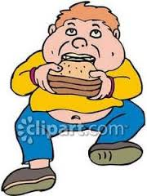
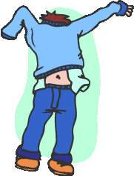
Arkadaşlarla takılmak
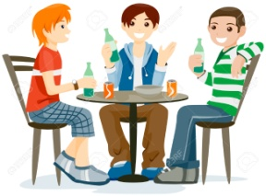
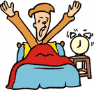

I ....................................... at  7 o'clock | I ....................................... ....................... after school | I ...................................................... on Sundays. | I ................................................... after school | I ............................................. after breakfast
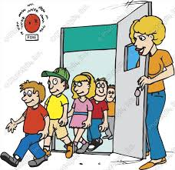
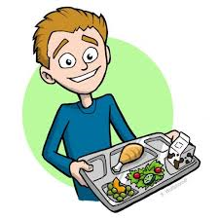
Okula gitmek Dersler başlar Eve gelmek
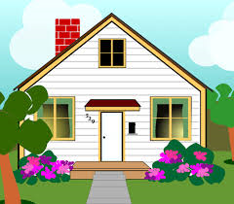
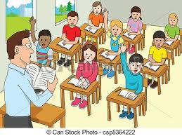

I .............................................  at 8:30 | ............................................ .............................. at 9:00 | I .................................................... in the canteen at 12:30 | ................................................... .. ................................ at 3:45 | Then I ...................................... ................................ at 4:10
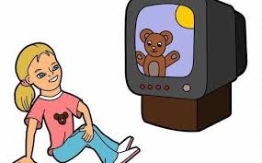
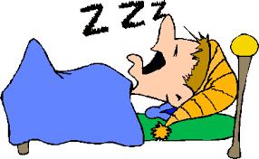
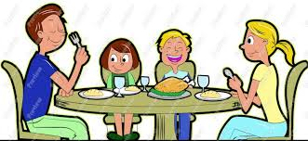
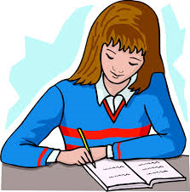
Dinlenmek

I .............................................  After school | I .......................................... in the evening | We .................................................... in the evening | I ................................................... after dinner | Then I ...................................... and sleep at 4:10

Prepared by Sinan Uzuner

