2019-2020 ACADEMIC YEAR Ş.M.Ç.B SECONDARY SCHOOL
1st TERM 2nd ENGLISH WRITTEN EXAM for 6th GRADES

Name-surname: Class: 6/ No: GRADE:_______/100

- Resimlerin altına doğru kelimenin NUMARASINI yazınız. (8x3=24 Pts)
1.Freezing 2.stormy 3.sunny 4.foggy 5.windy 6.cloudy 7.snowy 8.rainy

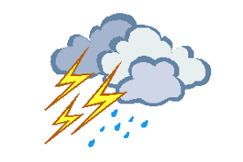
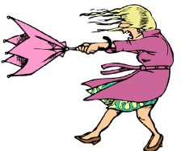

………… ..………… ……………. ……………… …..……… ..…….………… ……………… ……………

B. RESME GÖRE "HAVA NASIL?” VE “NE HİSSEDİYORSUN?” SORUSUNA CEVAP VERİNİZ’ (5x6=30)
Happy anxious moody sleepy scared

- It is ………………………………………………….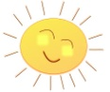 I feel…………………………………..
- It is …………………………………………………..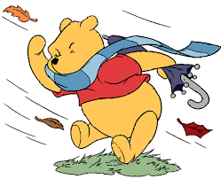 I feel…………………………………
- It is…………………………………………………….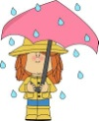 I feel ………………………………………….
- It is…………………………………………………….. I feel…………………………………….
- It is………………………………………………………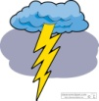 I feel …………………………………………..

C. SORULARI ÖRNEĞE GÖRE TABLODAKİ DUYGULARI KULLANARAK CEVAPLAYINIZ. (4x4=16)
Sad Happy Scared Sleepy

How do you feel on foggy days?
-I feel moody.
1. How do you feel on rainy days?
----------------------
2. How do you feel on stormy days?

3.How do you feel on snowy days?
----------------------------
4. How do you feel on windy days?
--------------------------
-------------------------------

D. RESİMDEKİLERİN ADINI BULARAK RESMİN ALTINA YAZINIZ. (6x5=30)
