2015-2016 EDUCATIONAL YEAR EKINCILER SECONDARY SCHOOL 2nd TERM 2nd EXAM FOR 6th GRADES
NAME/SURNAME: CLASS: NUMBER :

A.Kelime gruplarının anlamlarını yazınız (10)
Don’t cut trees :
Plant trees:
Listen to your teacher :
Save energy:
Protect animals:

B. Doğru olan kelimeyi yuvarlak içine alın.(15)
1. You should/shouldn’t throw away garbage.
2.After picnic we should make a fire/clean up the environment.
3. We should turn off the taps/Tv to save water.
4. We should buy products in harmful/recyclable containers.
5. We should/shouldn’t cut down trees.

C. Aşağıdaki resimlerin altına uygun bildiri/uyarı cümlelerini yazın.(15)
1.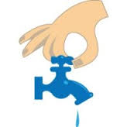
2.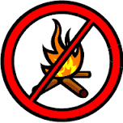
3.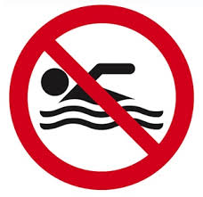.
4.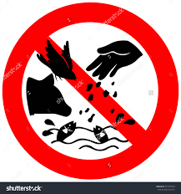
5.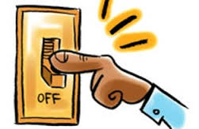
D)TURN DOWN TAPS
B)DON’T FEED THE ANIMALS
A)DON’T MAKE A FIRE IN THE WOODS
E)SWIMMING NOT ALLOWED
C)TURN OFF THE LIGHTS

D.Aşağıda verilen kelime gruplarını eşleştirin. (15)
1. A tailor can……. A) fly a plane
2. A teacher…….. B) at the police station
3. A pilot can……. C) cut and sew fabrics
4. You can see a doctor…….. D)teaches new things to students
5. A policeman works……… E) at the hospital
E. Aşagıdaki tarihleri okunuşlarıyla eşleştirin.(15)
1. 1997___ A) twenty-oh-five
2. 1700___ B) two thousand and sixteen
3.2016___ C) nineteen ninety-seven
4.1873___ D)seventeen hundred
5.2005___ E) eighteen seventy-three

F.DOĞRU SEÇENEĞİ İŞARETLEYİNİZ. (30)

1. Paula: I’m a _____ . I grow fruits and vegetables. What do you do?
Sharon: I’m a _____ . I work at a restaurant.
Yukarıdaki konuşmada boş bırakılan yerlere sırasıyla aşağıdakilerden hangileri getirilmelidir?
a) farmer / lawyer b) nurse / waitress
c) chef / hairdresser d) farmer / Chef

2. Aşağıdaki konuşmada boş bırakılan yere aşağıdakilerden hangisi getirilmelidir?
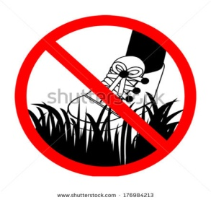
Kate: ____ ?
Jane: It was great. My family and I were in Paris. We visited the Eiffel Tower.
a) Where are you? b) How was your holiday?
c) Were you at school? d) How is your holiday?

*Aşağıdaki paragrafı okuyun ve sorulardaki doğru şıkları işaretleyin.
“Tarkan gave a concert in Antalya last weekend. Sixty-five thousand people watched the concert.
Nine hundred and forty-five security guards worked at the concert. He donated twenty thousand Turkish Liras to Kemer Animal Shelter.”

3.Where did Mr. Tarkan give a concert last weekend?
a) in Antalya b) last weekend
c) in Kemer d) concert

4. How many people watched the concert?
a) 945 b) 650 c) 6500 d) 65000

5. How much money did he donate to Kemer Animal Shelter?
a) 20000 b) 945 c) 12000 d) 20100

6. How many security guards were there at the concert?
a) 9045 b) 945 c) 9500 d) 940

7. What is he doing?
a) He is collecting the garbage.
b) He is putting the bottle into the recycle bin.
c) He is drinking water.
d) He is helping her father with cleaning.

8. Tabela aşağıdakilerden hangisini anlatmaktadır?

a) Keep off the grass.
b) Don't feed the animals.
c) Don't bath the animals.
d) Save the planet.

9. Bobby: What does rubbish mean?
Chuck: It means ______.
Yukarıdaki konuşmada koyu yazılmış kelimenin eş anlamlısı aşağıdakilerden hangisidir?
a) garbage b) reduce
c) device d) damage

10. Students ____ cheat in the exam.
a) should b) shouldn't c) must d) can

GOOD LUCK ☺

