ILLNESSES ( HASTALIKLAR )

A headache : baş ağrısı a temperature : ateşlenme
A toothache : diş ağrısı a stomachache : karın ağrısı
A cold : üşütme *flu : grip
A sore throat : boğaz ağrısı *the measles : kızamık
A backache :sırt ağrısı Runny nose:burun akıntısı
I I’ve got
You You’ve got
We have got We’ve got
They They’ve got

He He’s got
She has got She’s got
It It’s got
I don’t feel well. I have got a temperature. ( Kendimi iyi hissetmiyorum.Ateşim var. )
She has got a stomachache. ( Onun karnı ağrıyor. )
He has got a headache. ( Onun başı ağrıyor. )

A: What is the matter with you? ( Senin neyin var? )
B: I’ve got a toothache. ( Dişim ağrıyor. )

A: What’s the matter with Ayşe? ( Ayşe’nin neyi var? )
B : She’s got a headache. ( Onun başı ağrıyor. )

A: What’s the matter with Sinan?
B : He’s got the measles.

A: What’s the matter with Ayşe and Sinan?
B:They’ve got flu.
TEST 1

- He has got _______ flu.
a)the b) ___ c)a d)an

- She has got _____ temperature.
a)a b)an c)the d)____

- What’s the matter with Ayşe and Sevgi?
a)They has got a toothache.
b)She has got the measles.
c)He has got a sore throat.
d)They have got a temperature.

- A : What _____ the matter with Musa?
B : _____ has got a stomachache.
a)is / he b)is / she c)are / she d)am / he

- Oya ate a lot of chocolate.She has got ________.
a)a stomachache b)a headache
c)the flu d)the temperature

- I don’t feel well. I _________ stomachache.
a)haven’t got b)am c)was d)have got

- A: _________________? B: She has got flu.
a)What’s the matter with you?
b)What is the matter with them?
c)What is the matter with Ayşe?
d)What’s the matter with him?

- What’s the matter with Emre?
a)She has got a temperature.
b)He has got a headache.
c)They have got a sore throat.
d)She is got a toothache.

- I’ve got _____ measles.
a)a b)an c)the d)____

- A: ________________? B: She has got a cold.
a)What’s the matter with you?
b)What was the matter with you?
c)What is the matter with Kübra?
d)What’s the matter with Ahmet?

- Aylin drank a lot of cold water.Now she has got ___________.
a)the measles b)a toothache
c)a headache d)a sore throat

- 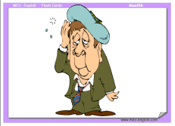 What’s the matter with him?
a)a headache. b)a toothache c)a toothache d)flu

- 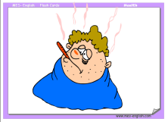 What’s the matter with him?
a)flu b)a headache
c)a sore throat d)a temperature

- 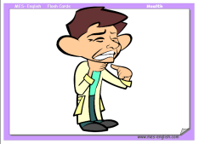 What’s the matter with him?
a)a stomachache b)a sore throat
c)a toothache d)a cold

- 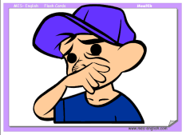 What’s the matter with him?
a)the measles b)flu
c)a toothache d)a sore throat

- A: What is the matter with you?
B: I ______ flu.
a)have got b)is c)am d)has got

-  What’s the matter with him?
a)a toothache b)the measles
c)flu d)a stomachache

- 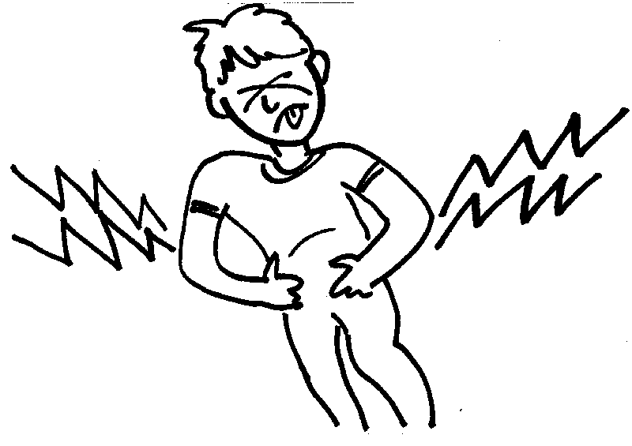What’s the matter with him?
a)a headache b)a toothache
c)a stomachache d)a cold

