DESCRIBING PEOPLE

Appearance and Personality

NOUNS
- height
- weight
ADJECTIVES
- adventurous
- ambitious
- arrogant
- attractive
- average
- beautiful
- bighead
- blond(e)
- boring
- calm
- chatty
- cheerful
- cold
- confident
- curly
- dark
- dishonest
- easy-going
- elegant
- enthusiastic
- fair
- fat
- flexible
- friendly
- funny
- generous
- good-looking
- gorgeous
- happy
- handsome
- hard-working
- heavy
- honest
- impatient
- independent
- interesting
- kind
- lazy
- light brown
- long
- mean
- middle-aged
- moody
- nice
- obese
- old
- optimistic
- ordinary-looking
- outgoing
- patient
- petite
- pessimistic
- pleasant
- plump
- polite
- pretty (often a girl)
- punctual
- quiet
- relaxed
- reliable
- reserved
- self-confident
- selfish
- sensible
- sensitive sensible
- short
- shoulder-length
- shy
- slim
- spiky
- stocky
- straight
- stout
- stubborn
- stupid
- successful
- tall
- teenager
- thin
- ugly
- unfriendly
- unkind
- well-built
- young

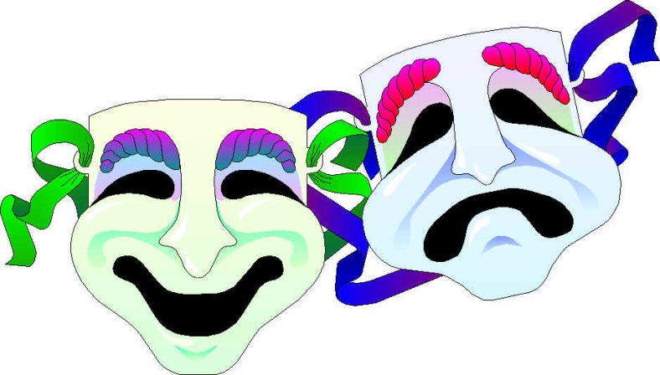
EXPRESSIONS
- overall appearance
QUESTIONS

To ask about people´s physical appearance we say:

WHAT + DO/DOES + SUBJECT + LOOK LIKE?
- What do you look like?
- What does he look like?
- What does she look like?
- What do they look like?
To ask about people´s character we say:

WHAT + BE + SUBJECT + LIKE?
- What are you like?
- What is he like?
- What is she like?
- What are they like?
To ask about people´s height we say:
- How tall are you?
- How tall is he?
- How tall is she?
- How tall are they?
To ask about people´s weight we say:
- How much do you weigh?
- How much does he weigh?
- How much does she weigh?
- How much do they weigh?
﻿﻿To ask about people´s age we say:
- How old are you?
- How old is he?
- How old is she?

