**…………………. MIDDLE SCHOOL 2016-2017 EDUCATIONAL YEAR ENGLISH LESSON 2ND TERM 2ND EXAM**

**Name:**

1. **Fill in the blanks with the correct words 10x2= 20 points**

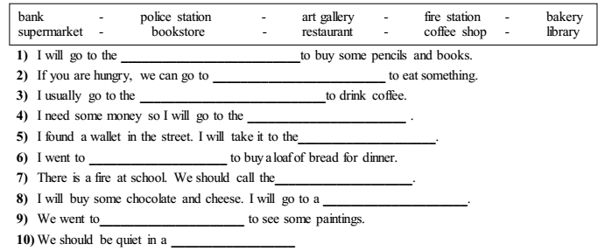

**B) Write the public buldings under the correct pictures 5x2= 10 points**

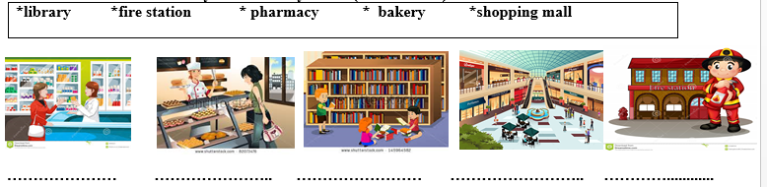

**C) Combine the sentences using “TO” (Cümleleri to kelimesini kullanarak tek cümle yapın) 5x2=10 points**

**1) I will go to the hospital. I will visit my grandfather.**

**……………………………………………………………………………………………**

**2) Sam should go to the library. He will study for his exam.**

**……………………………………………………………………………………….**

**3) David visited the art gallery. He wanted to see the new paintings.**

**…………………………………………………………………………………………**

**4) My mother bought some eggs, flour and butter. She wanted to make a cake.**

**………………………………………………………………………**

**5) If you want to buy books, you should go to the bookstore.**

**……………………………………………………………………………………..**

**D) Match the sentences** (Cümleleri harfleri yazarak eşleştirin) **(2x5=10p)**

**(...........)1. I need some money . a. Why don’t we go to a boutique and buy a costume?**

**(..........) 2. I am so fat. b. Let’s go to the bank.**

**(..........) 3. Look! There is £50 on the ground. c. Let’s go to a gym and exercise.**

**(..........) 4. There is a fancy dress party tonight. d. Why don’t we go out and have some fun?**

**(..........) 5. I’m bored. e. Let’s not take it. It isn’t ours.**

**E) Choose the best alternative 10x5=50 points**

**1. Steve: Where are you going?**

**Kate: I am going to the bakery. I will buy - - - - .**

a) new trainers

b) some bread and muffins

c) some medicine

d) some magazines

**2.** “Ceren is a superstitious girl. She is always taking her old coin with her when she has an exam. Her favorite fortune telling is card reading.She never opens umbrella indoors because she thinks it brings bad luck.”

**Yukarıdaki parçada aşağıdaki görsellerin hangisinden bahsedilmemiştir.**

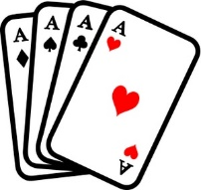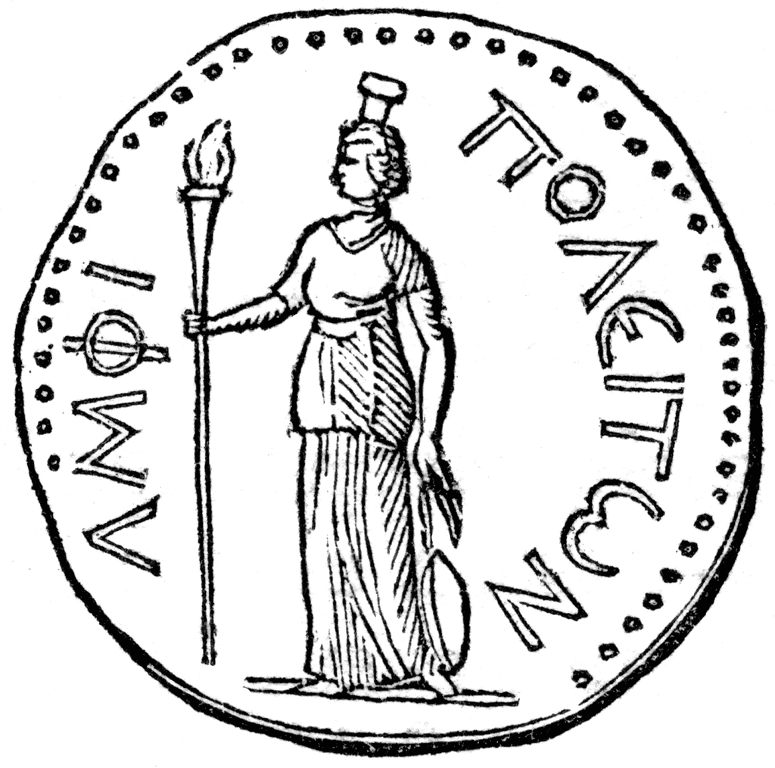

a) b)

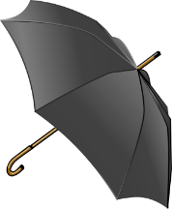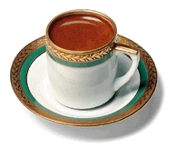

c) d)

**3. “**Last weekend, I went to the amusement park, bakery and shoe shop.”

**Yukarıdaki cümlede bahsedilmeyen görsel aşağıdakilerden hangisidir?**

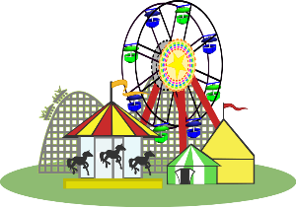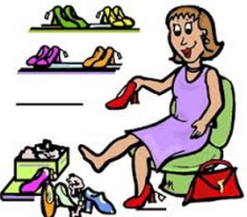

a) b)

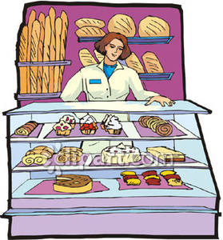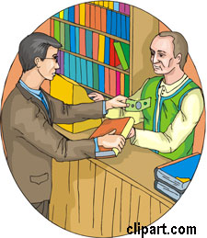

c) d)

**4.**

**Last Saturday, I went to the pharmacy to buy a medicine with mum.**

**Yukarıdaki metinde aşağıdakilerden hangisinin cevabı yoktur?**

a) Where were you last Saturday?

b) Who did you go there with?

c) What time did you go there?

d) Why did you go to pharmacy?

**5.**

**BRINGS BAD LUCK**

**- - - - - - - - - - - - - - - -**

**- - - - - - - - - - - - - - - -**

**Yukaridaki liste aşağıdakilerden hangisiyle tamamlanamaz?**

a) walking under a ladder

b) breaking mirror

c) finding four leaf clover

d) seeing a black cat

**6. You must call - - - - if there is a fire in your neighborhood.**

a) fire station

b) police station

c) boutique

d) florist’s

**7. Mary: Will I be successful in the future?**

**Fortune Teller: - - - - . You will be very successful.**

a) I hope, not

b) Definitely

c) No, you won’t

d) Of course, not

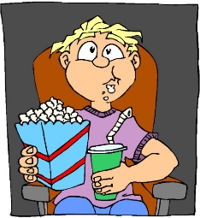**8. Sam was at the - - - - last**

**night.**

a) theatre

b) cinema

c) library

d) city hall

**9. One of your friends invites you to go to the fortune teller’s but you don’t believe in fortune telling. So say him;**

a) Sounds fun! Let’s go!

b) I am so excited. I want to learn my future.

c) That’s great! I love fortune telling.

d) No, thanks. I am not interested in fortune telling.

**10.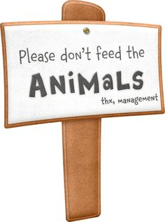 Where can you see that sign?**

a) At the zoo

b) At the library

c) At the pharmacy

d) At the shopping mall