In 2032, you will win the lottery!

C:\Users\Noémie\AppData\Local\Microsoft\Windows\Temporary Internet Files\Content.IE5\8K7H6G6D\MC900242017[1].wmf

In 2047, you will meet an extra-terrestrial!

C:\Users\Noémie\AppData\Local\Microsoft\Windows\Temporary Internet Files\Content.IE5\TH36VUMP\MC900281106[1].wmf

In 2047, you will fly to the Moon!

C:\Users\Noémie\AppData\Local\Microsoft\Windows\Temporary Internet Files\Content.IE5\S3KYHBA7\MC900229439[1].wmf

In 2025, you will be a famous rock star!C:\Users\Noémie\AppData\Local\Microsoft\Windows\Temporary Internet Files\Content.IE5\S3KYHBA7\MC900233431[1].wmf

In 2031, you will invent the first flying car!

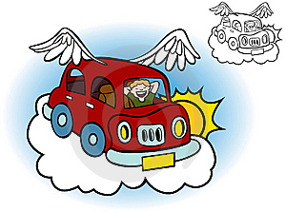

In 2024, you will get married!

C:\Users\Noémie\AppData\Local\Microsoft\Windows\Temporary Internet Files\Content.IE5\R5BU791U\MC900083467[1].wmf

In 2046, you will discover a new planet!

C:\Users\Noémie\AppData\Local\Microsoft\Windows\Temporary Internet Files\Content.IE5\S3KYHBA7\MC900199233[1].wmf

In 2050, you will be the President of France!



In 2023, you will write a best –seller!

C:\Users\Noémie\AppData\Local\Microsoft\Windows\Temporary Internet Files\Content.IE5\8K7H6G6D\MC900290053[1].wmf

In 2035, you will sail all around the world!

C:\Users\Noémie\AppData\Local\Microsoft\Windows\Temporary Internet Files\Content.IE5\8K7H6G6D\MC900296336[1].wmf

In 2047, you will travel in a time machine!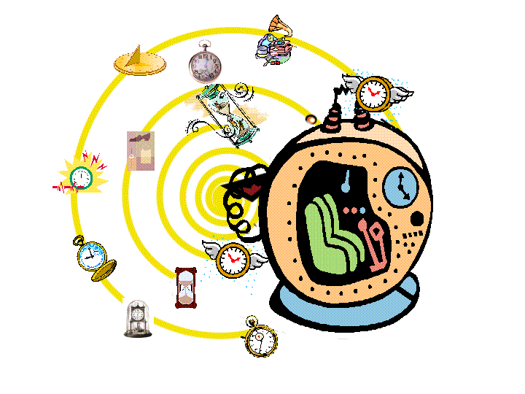

In 2042, you will have a robot to do the chores!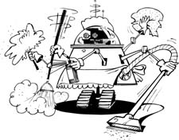

In 2050, you will find a cure to cancer!C:\Users\Noémie\AppData\Local\Microsoft\Windows\Temporary Internet Files\Content.IE5\S3KYHBA7\MC900280753[1].wmf

In 2026, you will drive a sports car!

C:\Users\Noémie\AppData\Local\Microsoft\Windows\Temporary Internet Files\Content.IE5\TH36VUMP\MC900079001[1].wmf

In 2041, you will live in Australia!

C:\Users\Noémie\AppData\Local\Microsoft\Windows\Temporary Internet Files\Content.IE5\TH36VUMP\MC900414968[1].wmf

In 2025, you will win the Olympic games!

C:\Users\Noémie\AppData\Local\Microsoft\Windows\Temporary Internet Files\Content.IE5\S3KYHBA7\MC900237916[1].wmf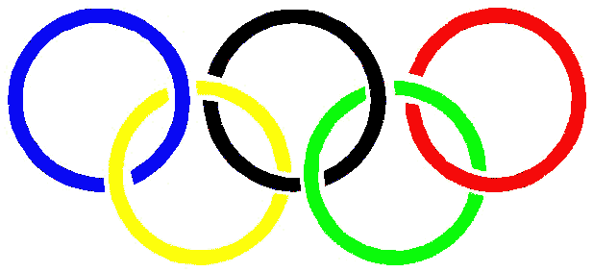

In 2027, you will have a baby

C:\Users\Noémie\AppData\Local\Microsoft\Windows\Temporary Internet Files\Content.IE5\TH36VUMP\MC900234503[1].wmf

In 2062, you will have a clone!

C:\Users\Noémie\AppData\Local\Microsoft\Windows\Temporary Internet Files\Content.IE5\8K7H6G6D\MC900235379[1].wmf

In 2025, you will speak 5 different languages!

