**Are you going to learn to drive? When? If not, why not?**

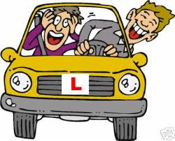

**Do you think you will get married? Why, why not?**

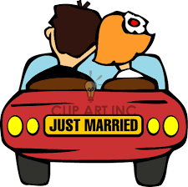

**Are you going to live abroad? In which country would you live?**



**What are you doing at the weekend?**



**Are you going on holiday this/next summer?**



**Are you going to learn another foreign language? Which one?**



**Are you planning to go to university?**



**What do you think the weather will be like tomorrow?**



**Do you think you will have children in the future? How many children would you like to have?**



**Do you think you’ll live in a house or in a flat in the future?**



**Are you meeting your friends today? Have you got any plans what to do?**



**Are you having any tests this/next week?**



**Do you think you will try an extreme sport in the future? Which one would you like to try?**



**Are you going to the cinema in the near future? Which film would you like to see?**



**What are you going to do after this lesson?**



**Do you think aliens will visit our planet one day?**

