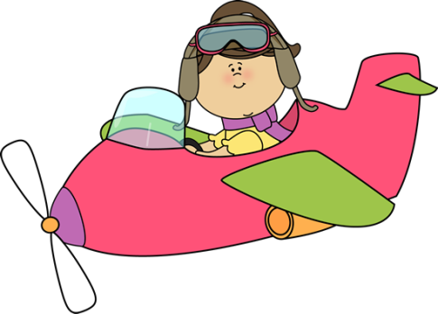

will or going to



Circle the correct answer

1. Oh look! It’s **is going to/ will** snow soon.

2. Next summer I **am going to/ will** backpack around Europe.

3. Ring! Ring! **I am going to/ I’ll** answer it.

4. I think our team **is going to/ will** win the match.

5. In 2055 robots **are going to/ will be** our teachers.

6. Tonight we **are going to have/ will have** a birthday party for my brother.

7. Sponge Bob **is going to/ will work** at the Crabby Patty tonight.

8. My friends **are going to/ will go** to the movies tonight.

9. I doubt that he **is going to/ will pass** the English test.

10. He **is going to/ will study** for the test tomorrow.

11. Be careful! You **are going to/ will drop** the dishes.

12. During summer vacation we **are going to/ will** **go** swimming every day.

13. I’m sure that you **are going to/ will find** your lost ring.

14. **I am going to/ will help** you carry your books.

15. Look out! That dog **is going to/ will bite** you if you get near him.

Fill in will or the correct form of am going to

1. Next Saturday we _________________ (attend) an NBA game.

2. I think the game ____________ (be) at the Olympic arena.

3. My father __________________(buy) tickets tonight.

4. _________ the Miami Heat _________ (win) the championship?

5. The weather ___________(be) dreadful tomorrow. But I doubt that it _____________(snow) in June.

6. We use the word(s) ________________ when we want to talk about predictions.

7. In 300 years people __________________ (travel) with flying cars instead of airplanes.

8. We use the word(s) _______________ when we offer to help someone.

9. I______________(lift) that heavy box for you.

10. I think that schools __________ (not/use) ______________ books- they _______ (give) every child a tablet computer.

11. When we speak about plans we use _______________________.

12. Later I ________________(read) a science fiction book on my e-reader.



Yes or no

1. **will** is used for plans _______________

2. **will** is used for predictions ______________

3. **am going to** is used for plans ____________

4. **will** is used for offers of help ____________

6. **will** is used for something likely to happen ______

7. **am going to** is used after I think ____________

8. **will** is used for decisions I make now __________

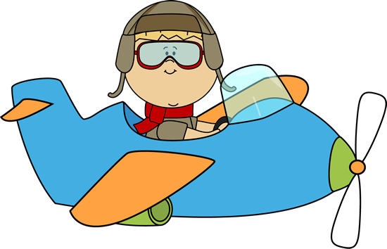







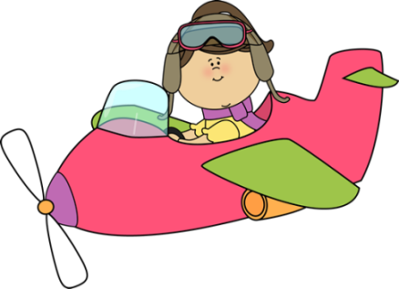

will or going to





Circle the correct answer

1. Oh look! It’s is going to/ will snow soon.

2. Next summer I am going to/ will backpack around Europe.

3. Ring! Ring! I am going to/ I’ll answer it.

4. I think our team is going to/ will win the match.

5. In 2055 robots are going to/ will be the teachers.

6. Tonight we are going to have/ will have a birthday party for my brother.

7. Sponge Bob is going to/ will work at the Crabby Patty tonight.

8. My friends are going to/ will go to the movies tonight.

9. I doubt that he is going to/ will pass the English test.

10. He is going to/ will study for the test last night.

11. Be careful! You are going to/ will drop the dishes.

12. During summer vacation we are going to/ will go swimming every day.

13. I’m sure that you are going to/ will find your lost ring.

14. I am going to/ will help you carry your books.

15. Look out! That dog is going to/ will bite you if you get near him.

Fill in will or the correct form of am going to

1. Next Saturday we _______________ (attend) an NBA game.

2. I think the game ____________ (be) at the Olympic arena.

3. My father __________________(buy) tickets tonight.

4. _________ the Miami Heat _________ (win) the championship?

5. The weather ___________(be) dreadful tomorrow. But I doubt that it _____________(snow) in June.

6. We use the word ________________ when we want to talk about predictions.

7. In 300 years people __________________ (travel) with flying cars instead of airplanes.

8. We use the word(s) _______________ when we offer to help someone.

9. ______________(lift) that heavy box for you.

10. I think that schools __________ (not/use) ______________ books- they _______ (give) every child a tablet computer.

11. When we speak about plans we use _______________________.

12. Later I ________________(read) a science fiction book on my e-reader.

Yes or no

1. **will** is used for plans _______________

2. **will** is used for predictions ______________

3. **am going to** is used for plans ____________

4. **will** is used for offers of help ____________

6. **will** is used for something likely to happen ______

7. **am going to** is used after I think ____________

8. **will** is used for decisions I make now __________



will or going to

Circle the correct answer

1. Oh look! It’s is going to will snow soon.

2. Next summer I am going to will backpack around Europe.

3. Ring! Ring! I am going to I’ll answer it.

4. I think our team is going to will win the match.

5. In 2055 robots are going to will be the teachers.

6. Tonight we are going to/ will have a birthday party for my brother.

7. Sponge Bob is going to will work at the Crabby Patty tonight.

8. My friends are going to will go to the movies tonight.

9. I doubt that he is going to/ will pass the English test.

10. He is going to study/ will study for the test tonight.

11. Be careful! You are going to will drop the dishes.

12. During summer vacation we are going to/ will go swimming every day.

13. I’m sure that you are going to will find your lost ring.

14. I am going to will help you carry your books.

15. Look out! That dog is going to will bite you if you get near him.

Fill in will or the correct form of am going to

1. Next Saturday we are going to attend (attend) an NBA game.

2. I think the game will be (be) at the Olympic arena.

3. My father is going to buy (buy) tickets tonight.

4. Will the Miami Heat win (win) the championship?

5. The weather will be (be) dreadful tomorrow. But I doubt that it will snow (snow) in June.

6. We use the word(s) will when we want to talk about predictions.

7. In 300 years people will travel (travel) with flying cars instead of airplanes.

8. We use the word(s) will when we offer to help someone.

9. I will lift (lift) that heavy box for you.

10. I think that schools won’t use /not(use) books- they will give (give) every child a tablet computer.

11. When we speak about plans we use am going to

12. Later I am going to read (read) a science fiction book on my e-reader.

Yes or no

1. **will** is used for plans NO

2. **will** is used for predictions YES

3. **am going to** is used for plans YES

4. **will** is used for offers of help YES

6. **will** is used for something likely to happen NO

7. **am going to** is used after I think NO

8. **will** is used for decisions I make now YES

Note: There are a lot of sentences with will. Generally we use am going to for the future, but in special cases we use will. Students should be aware of these special cases.