1 - 3. soruları aşağıda verilen ifadelere göre cevaplayınız.
Adventures – I
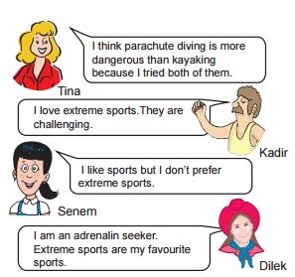

1. - - - - doesn’t want to go to rafting.
A) Dilek B) Kadir C) Senem D) Tina
2. According to the text, - - - - .
A) Dilek likes doing dangerous sports B) Kadir prefers only parkour running C) Senem loves all extreme sports D) Tina didn’t do extreme sports before
3. Which one is true?
A) Dilek is less adventureous than the others. B) Kadir never wants to feel adrenalin by doing sports. C) Senem prefers doing extreme to indoor sports. D) Tina is experienced about some extreme sports.
4 - 6. soruları aşağıda verilen parçaya göre cevaplayınız.
Rachel: Last summer, I went to Nevşehir with my friends Kate, Jane and Peter. I tried a hot air balloon ride. It was fascinating and exciting but it was also dangerous. So, my friend Kate didn’t do it. Then we went to Muğla. We enjoyed rafting but I think that the hot air balloon was more entertaining and exciting than it.
4. Yukarıdaki paragrafın ilk kısmında anlatılan aktiviteyi ifade eden görseli işaretleyiniz
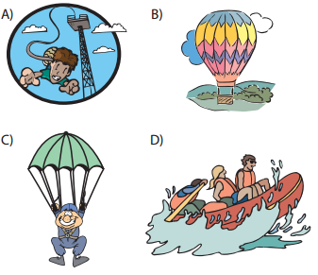

5. Kate - - - - .
A) didn’t go to Nevşehir B) liked rafting and scuba diving C) didn’t try hot air balloon riding D) was pleased with her summer holiday
6. Rachel - - - - .
A) went to Muğla and then Nevşehir B) didn’t enjoy her hot air balloon ride C) loves her friends but they don’t like her D) thinks rafting is less exciting than hot air balloon riding
7. Dangerous activities such as rafting, bungee jumping, kayaking are also called - - - - .
A) adrenalin seekers B) extreme sports C) first - aid kits D) sport centres
8. Leo : - - - - ? Hasan : I really enjoy going rafting.
A) What does your sister enjoy doing in her summers B) Do you prefer cooking at home or eating fast food C) Did you see me while I was rafting yesterday D) What do you like doing on your holidays
9. Özge : I think skateboarding is dangerous. Sam : Yes, but it is exciting. Özge : - - - - ? Sam : Yes, I did it.
A) Did you have a chance to try it B) Did you know where my helmet was C) Did you join a teen festival when you were 15 D) Where and when did your brother try skateboarding
10. I prefer trekking to jogging because it is more entertaining and - - - - for me.
A) fascinating B) dangerous C) boring D) tiring
11. “Parachute diving is less dangerous than hang gliding.” Yukarıdaki cümleye anlamca en yakın cümle aşağıdakilerden hangisidir?
A) The most dangerous sport is parachute diving. B) Hang gliding is easier than parachute diving. C) Hang gliding is more dangerous than parachute diving. D) Parachute diving is as dangerous as other extreme sports.
12. Gül : My brother and I tried a new activity last Saturday with my brother. It was fun. In this activity, it is important that you have a pair of good trainers because it has a parkour. You have to run, jump and climb but you cannot use any equipment. You have to be quick. Gül aşağıdaki aktivitelerden hangisinden bahsetmektedir?
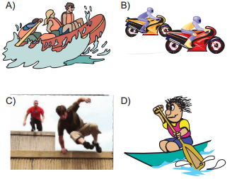

Adventures – II
1.Emily: Do you like windsurfing? Robert: Yes, but I would rather go rafting because it is safer. Emily: - - - - I think windsurfing is less dangerous.
A) That sounds fun. B) I disagree with you. C) I agree with you. D) What a nice idea!
2.Lynn: Why do you prefer bungee jumping to canoeing? Jason: Because bungee-jumping is more - - - - .
A) boring B) amusing C) terrible D) disappointing
3. Jane: Did you try rafting when you were in Fethiye last summer? Nick : Yes, I did. Jane: How did you feel when you were doing it? Nick : I loved it and it was really - - - - .
A) ridiculous B) unbearable C) narrative D) heart-stopping
4.Sandy: I think you like safety sports most. Mathew: You are wrong. To me, - - - - .
A) kayaking is more boring B) basketball is more entertaining C) parkour running is more challenging D) parachute diving is more fascinating
5.Margaret: - - - - ? Dylan: I think they like to push and test themselves.
A) Why do people like dangerous sports B) Do you think that people enjoy freedom C) Which extreme sports do people like most D) Do people want to talk about extreme sports
6. Bungee jumping, sky diving and motor racing are some examples of the - - - - .
A) indoor activities B) adventure sports C) medical treatments D) adrenalin seekers
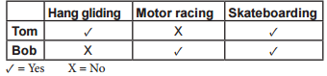

7.Yukarıda verilen tabloya göre doğru olan ifadeyi işaretleyiniz.
A) Tom prefers hang gliding to skateboarding. B) Tom would rather go motor racing than skateboarding. C) Bob prefers hang gliding to motor racing. D) Bob would rather go skateboarding than hang gliding

8. ‘I always do outdoor sports. My friends and I enjoy moving quickly between buildings and the objects in the city. We perform jumps and other skillful moves.’
Yukarıda verilen bilgiyi ifade eden görseli işaretleyiniz
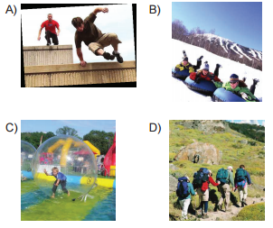

9. (I) I would rather go trekking than rock climbing because it is easier.(II) So I joined a trekking club last year. (III) I am an adrenalin seeker. (IV) I went to forest the with club members for that sport the previous weekend.
Yukarıda verilen paragrafın anlam bütünlüğünü bozan cümleyi işaretleyiniz.
A) I B) II C) III D) IV
10 - 11 - 12. soruları aşağıda verilen diyaloğa göre cevaplayınız.
Angle : Tom, are you a member of a club now? Tom : Unfortunately, no. But when I was in high school, I joined caving and cycling clubs. One day, we went riding up the hills near our town. Bill, a friend fell off his bike and injured his arm. We were all scared but there wasn’t anything serious. Fortunately, we all had our safety gear on, we put on our helmets and gloves before the accident. They saved his life.
10. According to the text, - - - - .
A) Tom is member of a sports club in his town now B) Tom’s arm and foot were injured during a bike ride C) only Brian wore a helmet and bike riding shoes D) Tom was a member of a sports club when he was in high school
11. Bill took safety items like - - - - .
A) helmets and gloves B) bike riding shoes C) first-aid kits D) footwears
12. Where did they cycle?
A) In the city center. B) Up a hill. C) In a cave. D) At school.

Adventures – III
1. “Martin prefers pocket bike riding to parkour running.” Yukarıda verilen bilgiyi ifade eden görseli işaretleyiniz
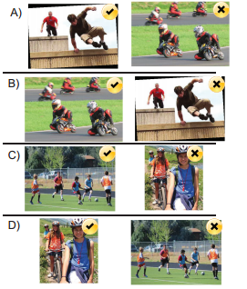

2.Harry: What’s your favourite sport? Dean: - - - - because it is challenging.
A) Fascinating B) Entertaining C) Base jumping D) Heart stopping
3. Michael: - - - - ? Daniel : About 18 kilos.
A) How much does a mini motorbike weigh B) How fast is a mini motorbike in a race C) Where did the concept of motorbike begin first D) Is a mini motorbike heavier than a normal motorbike
4. Lisa : Who do you usually do sports with? Helen : - - - - .
A) By bus B) At the sports club C) In the evenings D) With my buddies
5. I like bike competitions most so - - - - .
A) I would rather join a cycling team B) I prefer extreme sports firstly C) I am a real adrenalin seeker D) I am good at riding horses
6. Jack : I will join the extreme sports competition. Jennifer: How exciting! Jack : Yes, I can’t wait any more. Jennifer: - - - - ? Jack : $7
A) How fast are you B) When is the competition C) Where is the event taking place D) How much is the registration fee
7. Lisa : I am planning to try parachute diving next summer. Would you like to join me? Helen: Yes, - - - - . I am a real adrenalin seeker.
A) that sounds interesting B) that is not very good C) that’s unbearable D) that’s not true
8. Verilen eşleştirmelerden doğru olanı işaretleyiniz.
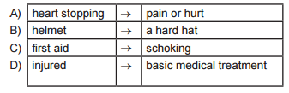

9. I. Because it is dangerous. II. I would rather do extreme sports. III. I need some sports safety items for doing it. IV. One of them is base jumping. Cümleleri anlamlı bir bütün oluşturan sıralamayı işaretleyiniz.
A) II - IV - III - I B) IV - II - III - I C) IV - III - I – II D) II - III - IV – I
10 - 11 - 12. soruları aşağıda verilen parçaya göre cevaplayınız
Hi! I am Leo. I am a university student who is interested in doing extreme sports such as rafting, caving, hang gliding, kayaking etc. I also organise sports tours for university students every year as a hobby. The previous year we went to Ürgüp. There, we enjoyed a hot air balloon ride. Most of my friends found the scenery fascinating. Last year, we went to Fethiye and we tried rafting. It was really difficult and dangerous. I think I will organise a hang gliding tour to Antalya next year.
10. They went to hot air balloon riding - - - - .
A) next year B) this year C) every year D) two years ago
11. According to the text, which one is true?
A) Leo organized a tour to Antalya last year. B) Leo graduated from a high school. C) Leo is a professional tour guide. D) His friends liked hang gliding.
12. Leo’s friends loved - - - - .
