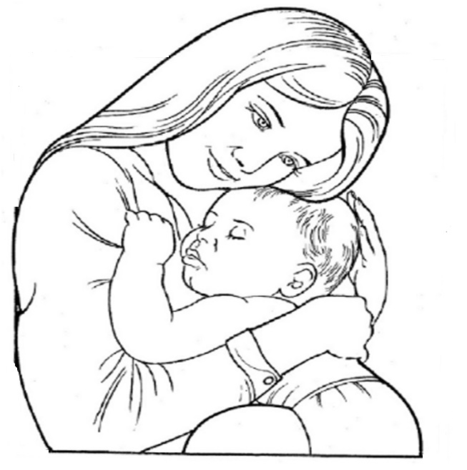

…………………………………………………………………………………………………………………………………………………………………………….…………………………………………………………………………………………………………………………………………………………………………….…………………………………………………………………………………………………………………………………………………………………………….…………………………………………………………………………………………………………………………………………………………………………….…………………………………………………………………………………………………………………………………………………………………………….…………………………………………………………………………………………………………………………………………………………………………….……………………………………………
www.mustafa-turan.com

