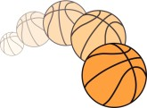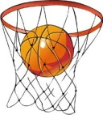

1

1. A net fixed on a hoop used as the goal.

2. A pass to a team mate that leads directly to a goal.

3. The round metal rim from which a basketball net is suspended.

4. What is MVP (award) short for?

5. At what height must a basket ring be?

6. Which kind of baset was first used for the game?

7. What was the nickname of a famous Michael playing for LA Lakers?

8. What is a ball called coming off the backboard?

9. If a player commits a foul, the referee awards a free _ _ _ _ _.

10. A high jump shoot in which the ball is thrust down through the hoop.

11. a player loses the ball to a member of the other team without taking a shot.

12. An official who calls violations and fouls.

13. To bounce the ball repeatedly with one hand while running.

14. If you run with the ball you must also _ _ _ _ _ _ it.

15. Every year new players in the NBA league are found in the _ _ _ _ _.

16. Number of points earned when shooting from inside the 3-point line.



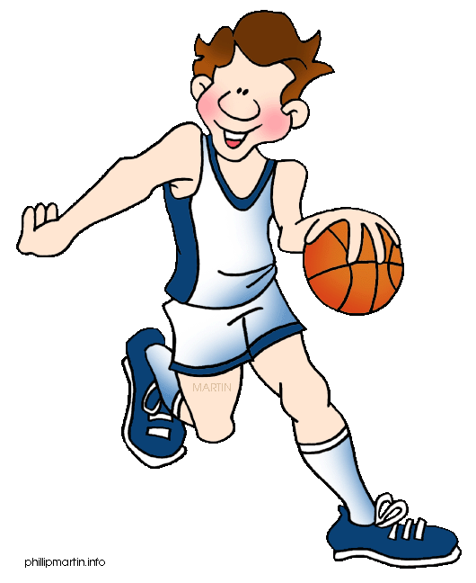6. Which



1

1. A net fixed on a hoop used as the goal.

2. A pass to a team mate that leads directly to a goal.

3. The round metal rim from which a basketball net is suspended.

4. What is MVP (award) short for?

5. At what height must a basket ring be?

6. Which kind of baset was first used for the game?

7. What was the nickname of a famous Michael playing for LA Lakers?

8. What is a ball called coming off the backboard?

9. If a player commits a foul, the referee awards a free _ _ _ _ _.

10. A high jump shoot in which the ball is thrust down through the hoop.

11. a player loses the ball to a member of the other team without taking a shot.

12. An official who calls violations and fouls. (REFEREE)

13. To bounce the ball repeatedly with one hand while running.

14. If you run with the ball you must also _ _ _ _ _ _ it.

15. Every year new players in the NBA league are found in the _ _ _ _ _.

16. Number of points earned when shooting from inside the 3-point line.

T

U

R

E

N

O

V

R

U

L

A

V

T

M

O

H

O

O

P

A

S

S

I

S

T

E

K

S

A

B

B

O

U

T

H

R

W

N

C

R



E

E

L

F

A

A

E

M

I

6. Which

W

T

TD

F

A

R

E

E

R

D

R

I

B

B

E

K

N

U

D

R

E

B

O

D

U

R

J

O

R

D

N

A

L

A

U

N

D

R

T

E

N

F

T

E

R

E

Y

A

L

P

E

L

B

A