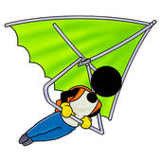[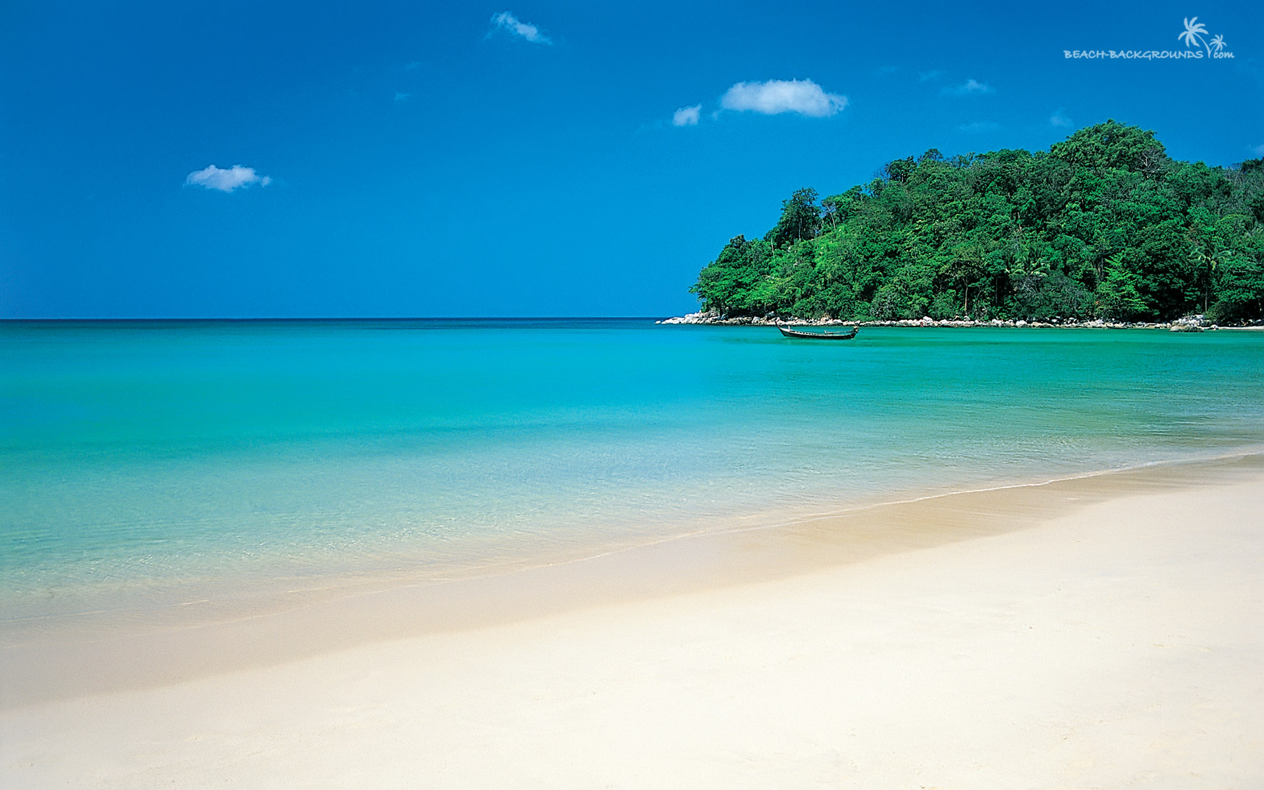](http://www.google.com.br/url?sa=i&rct=j&q=BEACH+PHOTO&source=images&cd=&cad=rja&docid=vCzSqNJX6QlU2M&tbnid=qAZndhNqGV3ERM:&ved=0CAUQjRw&url=http://www.beach-backgrounds.com/green-island-beach-background/&ei=KuQ9UcbkC8GnqgHgoYGYBA&bvm=bv.43287494,d.dmQ&psig=AFQjCNEHO0qIxAkh_mxwOZWEI4AZWwp32A&ust=1363096709314907)

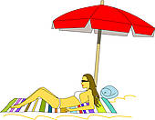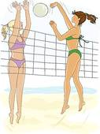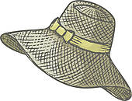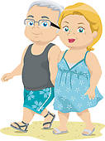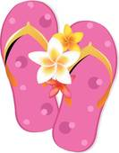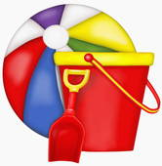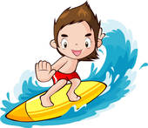[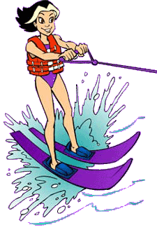](http://www.google.com.br/url?sa=i&rct=j&q=WATER+SKIING+CLIPART&source=images&cd=&cad=rja&docid=KuTK3d9vaXRXIM&tbnid=UaXID3K1KCzCMM:&ved=0CAUQjRw&url=http://www.cksinfo.com/sports/skiing/page4.html&ei=Je49UYrCDsLlqgHxzYF4&bvm=bv.43287494,d.dmQ&psig=AFQjCNG7AF1koWSqcIAsNMaqI1DrWwPD_w&ust=1363099514026439)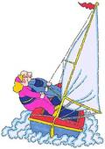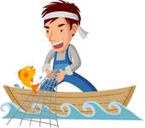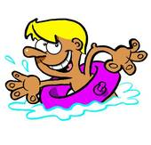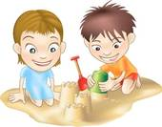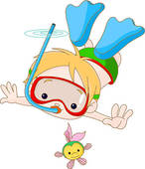

EISSTAND

GLEITSCHIRM FLIEGEN

WASSERSKI FAHREN

JETSKI

SANDALEN

BADETUCH

SPAZIEREN GEHEN

SONNEN BADEN

SCHAUFEL

KÜBEL

BALL

SCHWIMMEN

HUT

VOLLEYBALL SPIELEN

SONNENSHIRM

SURFEN

SEGELN

EINE SANDBURG BAUEN

FISCHEN

TAUCHEN