**Look and circle !**

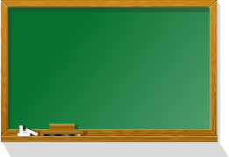

**1.** eraser / window 8.board/ crayon

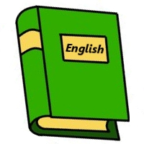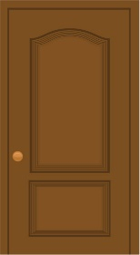

**2.**door / book 9.book/ desk

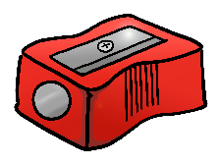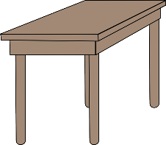

**3.**table / scissors 10.ruler / pencil

sharpener

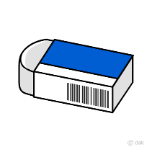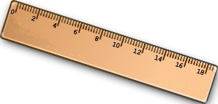

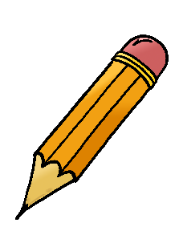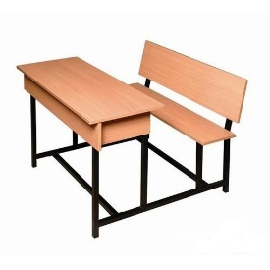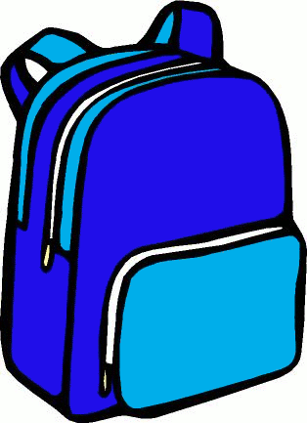 **4**.Pencil / ruler 11. Eraser / table

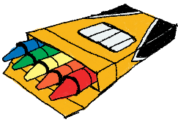

5. school bag/ board 12.crayon / pencil

6. desk / table 13. door / pencil

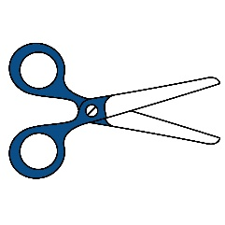

7. pencil / scissors 14. book / notebook

sharpener

HOW MANY ?

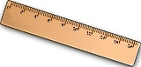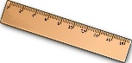 There are ___________ ____________

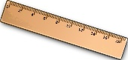



There is ___________ ___________

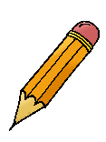

There are ___________ ____________



There are ___________ ____________



 There are ___________ ____________





There are ___________ ____________



 There are ___________ _____________