- PRESENT CONTINUOUS TENSE or SIMPLE PRESENT TENSE ? (20p)
1 I always (go) to cinema at weekends.
2 She never (smoke) cigarettes.
3 He (sleep) at home now.
4 She (not/like) reading books.
5 We (watch) TV at the moment.
6 you (do) your homework right now?
7 Sue rarely (cook).
8 Bill sometimes (fly) to Paris at weekends.
9 Look! She (jump) into the sea.
10 The sun (rise) in the east.

- Look at the Picture. Write questions. Then use the verbs in the list to answer them.(30p)
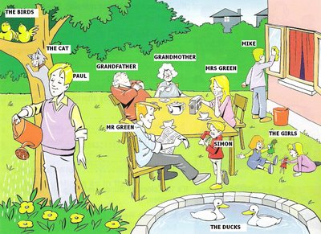
*play with dolls
* clean the window
* listen to radio
* sleep
*water the plants

Ex. The birds/ watch TV?
Are the birds watching TV? No, they aren’t. They’re singing.

- The girls / do their homework?

- Mrs. Green / eat?

- Grandfather / play video games?

- Mike / playing samba music?

- Paul / read magazine?

- Circle the correct choice or fill in the blanks. (20p)

A: What’s the weather like?
B: It’s_____.
- Are you eating a sandwich now?
____________.
- Tony is in Maldives. He’s__ on the beach now.
- Shopping b) dancing c) sunbathing
- I’m in Spain. I’m __ flamenco.
- Going b) dancing c) sunbathing
- Phil’s __ pictures of ancient temple.
a)Taking b) going c) playing

Write the times
- 02:30 ________________/___________________
- 06:15 ________________/___________________
- 08:45 ________________/___________________
- 10:20 ________________/___________________
- 11:50 ________________/___________________

Fill in at/on/in
- ___ Tuesday
- ___ the summer
- ___ the weekend
- ___ night
- ___ Saturday morning

Make sentences with frequency adverbs given
- She is late for work ( never)
____________________________
- Jane cooks diner for her family (often)
_____________________________

- ____ dressed
- Go b) get c) have
- ____ dinner
- Go b) get c) have
- ____ to bed
- Go b) get c) have

- Fill in the blanks with does / is ( 15p)
A: _____ your mum like playing video games?
B: Yes, she ____
A: And what about your brother? ____ he play any video games?
B: Well, he ____ a very good player.
A: Every day?
B: No, he ____ usually very busy.

- Choose one of the topics and write at least 30 words. (15p)

- Imagine you’re in Rio Carnival and you are a reporter. Report the event using Present continuous Tense
or
- Imagine that you’re on holiday with your family. Write what you are doing at the moment.

