**[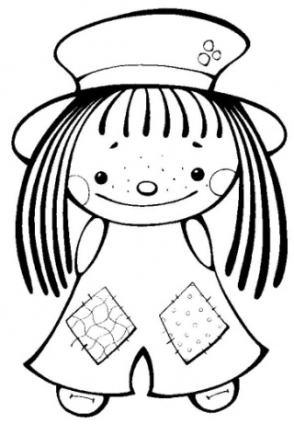](http://www.supercoloring.com/image_print.php?img_src=http://www.supercoloring.com/wp-content/original/2008_12/cute-girl-coloring-page.jpg)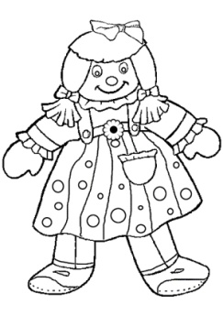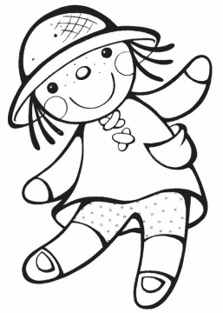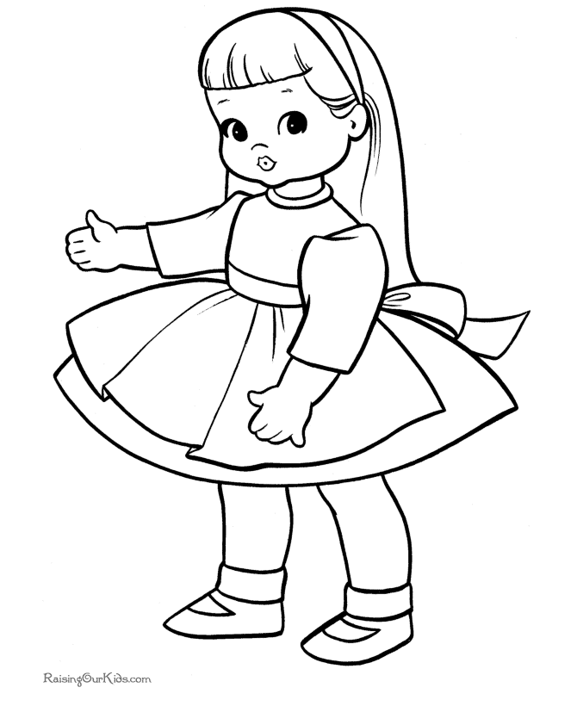[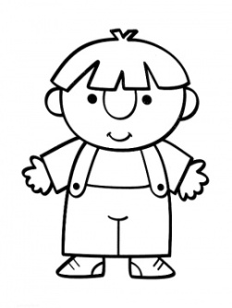](http://www.supercoloring.com/pages/opened-hand/)[](http://www.supercoloring.com/pages/opened-hand/)EŞİNİ BUL**