21
GO FORWARD 2 SQUARES
23

22
Go and show something on the map.
8
You need an eraser.

13
Pick up the calculator for your math test.

32

MISS A TURN

37
It’s computer class.

START
1
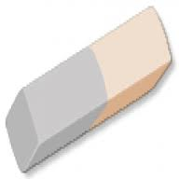
4
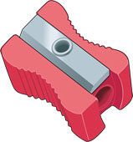
3
Take notes in your notebook.

2

6

7

MISS A TURN

9

11
Go back and sharpen your pencil.
12
16
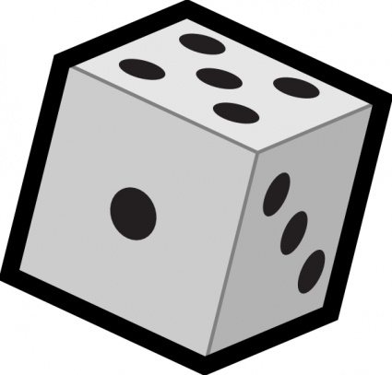

31
26
27
17
You forgot your homework. Go back to the start.
33
The teacher asks you to open your book.
36

38
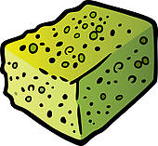
39

41
GO BACK 3 SQUARES

42
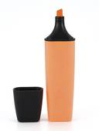
43
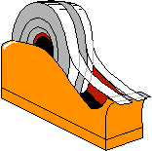
44
You need scissors.
45
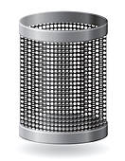
5
10
14
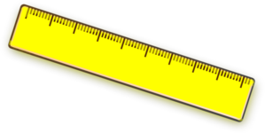
18
28
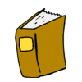
34
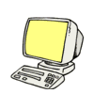
40

FINISH
15
The teacher asks you to come to the board.
19
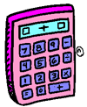
24
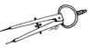
25
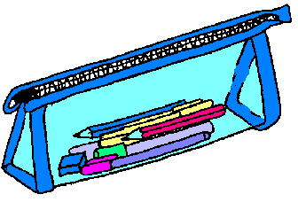
29

GO BACK 3 SQUARES

20
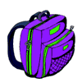

30

35
ANSWERS

21
GO FORWARD 2 SQUARES
23
GLUE

22
Go and show something on the map.
8
You need an eraser.

13
Pick up the calculator for your math test.

32

MISS A TURN

37
It’s computer class.

START
1
ERASER
4
PENCIL SHARPENER
3
Take notes in your notebook.

2
PEN

6

STAPLER

7

MISS A TURN

9
MAP

11
Go back and sharpen your pencil.
12
PENCIL
16

31
PAPERCLIP
26
27
CHALK
17
You forgot your homework. Go back to the start.
33
The teacher asks you to open your book.
36
PAPER

38
SPONGE
39

41
GO BACK 3 SQUARES

42
MARKER / HIGHLIGHTER
43
TAPE
44
You need scissors.
45
DUSTBIN
5
10
NOTEBOOK
14
RULER
18
BOARD
28
BOOK
34
COMPUTER
40
GLOBE

FINISH
15
The teacher asks you to come to the board.
19
CALCULATOR
24
COMPAS
25
PENCIL CASE
29

GO BACK 3 SQUARES

20
BACKBAG

30
SCISSORS

35
CRAYONS

Instructions for the teacher.

Preparation
- Print the board games on tick paper or a cardboard; laminate them if you want to use them many times.
- Find tokens for each student.
- Provide dice.
- Divide the class into groups of 3 – 4 students each.
- Give each group a board game and a die.
- Give each student a token (or bean, coin, button, etc.).

The game
- The players put their tokens on the first square.
- The first student throws the die and moves his token ahead the corresponding number of squares.
- The student answers the question with a whole sentence or follows the instruction. More advances students could say what they can do with the different items.
- Example: This is a pen. I can write my homework with a pen.
- If the answer is correct, the student stays, if the answer is incorrect, he has to go back where he came from.
- If the student comes to a square with the symbol , he rolls the die again.
- The first student who takes a number that places his token on “FINISH” or surpasses it is the winner.

