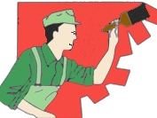

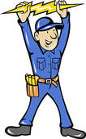







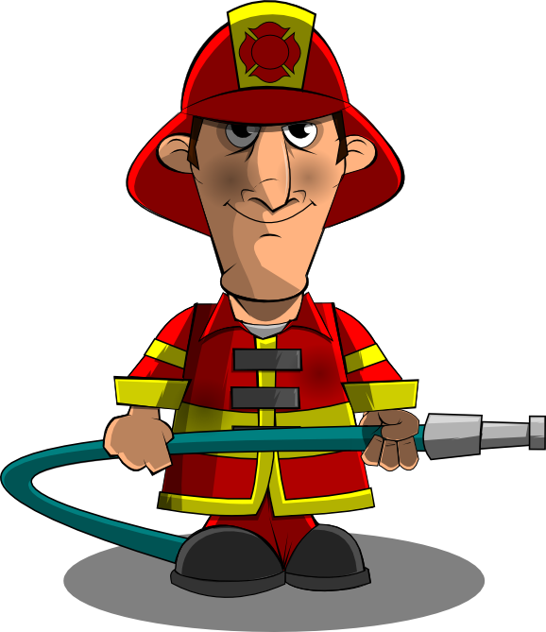

Your neighbor’s house is on fire.

START





Your animal is sick.



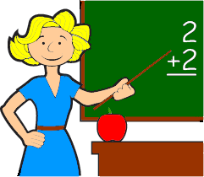

Your car won’t start.

The police are searching a criminal.

He is going to serve your meal.

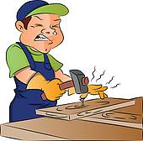

You are drowning in the pool.

You need a haircut

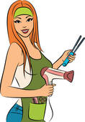

She is going to sew a new dress for you.



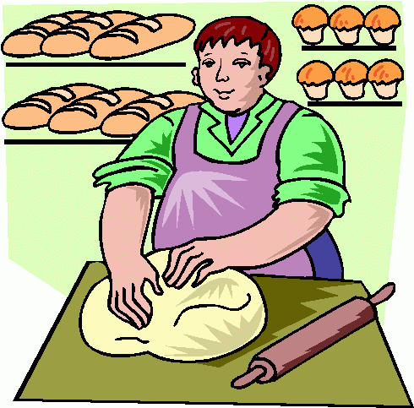

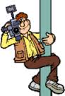



He is going to carry your luggage.

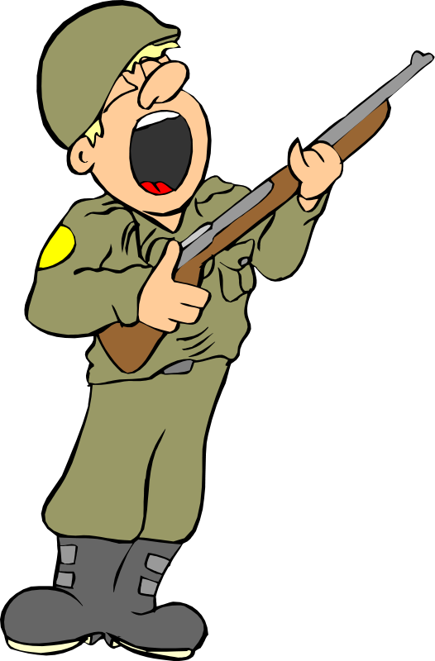



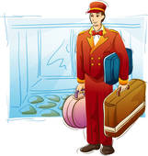

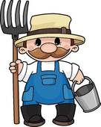

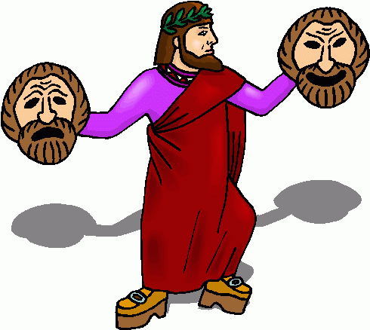





You are sick.

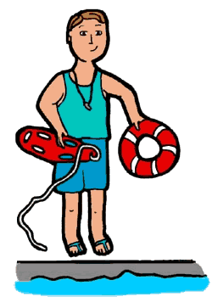

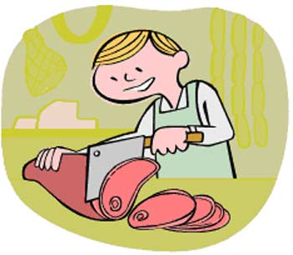

Go and buy some fresh meet.



FINISH





You don’t have any more bread at home.

[](http://www.google.com.br/url?sa=i&rct=j&q=SALEMAN+clipart&source=images&cd=&cad=rja&docid=QNyS24KtjVzc9M&tbnid=xlOMquIlhJctSM:&ved=0CAUQjRw&url=http://www.clipartheaven.com/show/clipart/occupations/cartoons_(a_-_l)/car_salesman-gif.html&ei=bd85UfeZCJTK9QS9k4H4AQ&bvm=bv.43287494,d.dmQ&psig=AFQjCNFLRROwJmqp2QJmH-JyoQh6HtolUg&ust=1362833628799988)



You want to buy a new car.

You have a toothache.



**ANSWERS**



PAINTER



ELECTRICIAN



PLUMBER



DOCTOR



ARCHITECT



FIREFIGHTER

Your neighbor’s house is on fire.

START





COOK / CHEF

Your animal is sick.





TEACHER

Your car won’t start.

The police are searching a criminal.

He is going to serve your meal.



CARPENTER

You are drowning in the pool.

You need a haircut



HAIRDRESSER

She is going to sew a new dress for you.



POSTMAN



BAKER



PHOTO-GRAPHER



JOURNALIST

He is going to carry your luggage.



SOLDIER



PILOT



BELLBOY



FARMER



ACTOR



MECHANIC



VET

You are sick.



LIFE GUARD



BUTCHER

Go and buy some fresh meet.



NURSE

FINISH



WAITER



SEEMSTRESS

You don’t have any more bread at home.

[](http://www.google.com.br/url?sa=i&rct=j&q=SALEMAN+clipart&source=images&cd=&cad=rja&docid=QNyS24KtjVzc9M&tbnid=xlOMquIlhJctSM:&ved=0CAUQjRw&url=http://www.clipartheaven.com/show/clipart/occupations/cartoons_(a_-_l)/car_salesman-gif.html&ei=bd85UfeZCJTK9QS9k4H4AQ&bvm=bv.43287494,d.dmQ&psig=AFQjCNFLRROwJmqp2QJmH-JyoQh6HtolUg&ust=1362833628799988)

SALESMAN



JUDGE

You want to buy a new car.

You have a toothache.



**Instructions for the teacher.**

**Preparation**

* Print the board games on tick paper or a cardboard; laminate them if you want to use them many times.
* Find tokens for each student.
* Provide dice.
* Divide the class into groups of 3 – 4 students each.
* Give each group a board game and a die.
* Give each student a token (or bean, coin, button, etc.).

**The game**

* The players put their tokens on the first square.
* The first student throws the die and moves his token ahead the corresponding number of squares.
* The student says the word according to the picture or follows the instructions and goes to the mentioned word. More advanced students can say a sentence.
* **Example: Your car won’t start. – I’ll take it to the mechanic.** If the answer is correct, the student stays, if the answer is incorrect, he has to go back where he came from.
* The first student who takes a number that places his token on “FINISH” or surpasses it is the winner.