Ask and answer: What… … ? www.egitimhane.com


Write

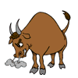
- What animals is this? It’s a…………..
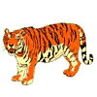

- What animals is this? It’s a…………..
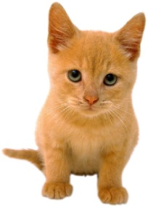

- What animals is this? It’s a…………..
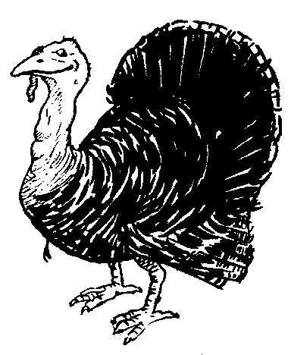
- What animals is this? It’s a…………..
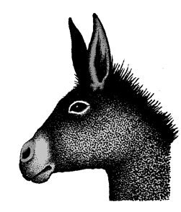

- What ‘s your favourite animal? I like…………..

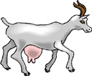

- What ‘s your favourite animal? I like…………..

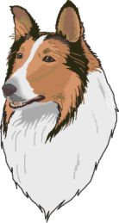

- What ‘s your favourite animal? I like…………..
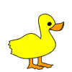
- What ‘s your favourite animal? I like…………..
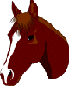
- Do you like horses ? Yes, I do. No, I don’t.
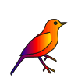
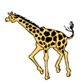
10.Do you like birds ? Yes, I do. No, I don’t.

11. Do you like giraffes ? Yes, I do. No, I don’t.
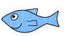

12.Do you like fish? Yes, I do. No, I don’t.
Word bank
dog – horse – fish- bird – duck-cats-goat-sheep-bull-tiger- cow
lion - turkey – pig – hippo - sheep - zebra – rabbit-donkey-camel

