WHAT CAN THESE ANIMALS DO? – WHAT CAN’T THEY DO?
www.egitimhane.com
animal | run | talk | fly | climb | swim | dive | crowl | sing
a snake
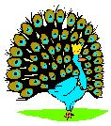
a peacock
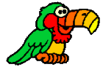
parrot
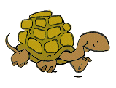
turtle
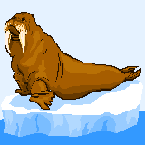
a seal

a squirrl
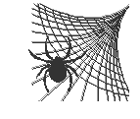
a spider
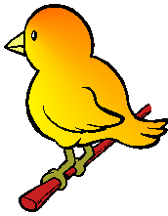
a bird
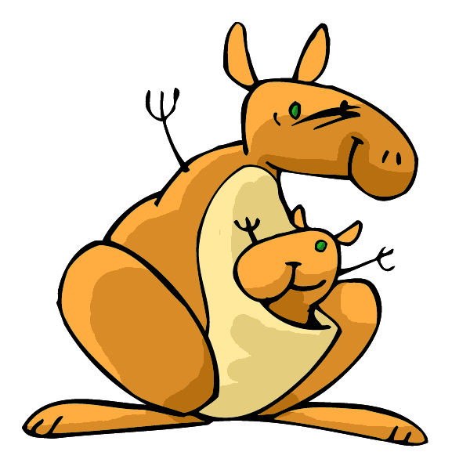
a kangaroo

Ex. A snake can crowl, but it can’t run.

