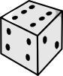
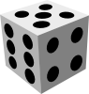
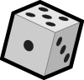
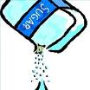
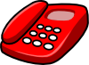

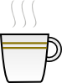
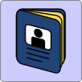

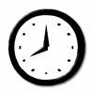
What's this?
Start
Finish
Board
Game
It’s a …
(one item)

It’s …
(uncountable)
They’re …
(more than 1)

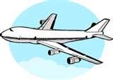
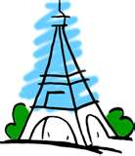

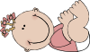
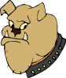

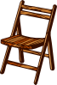
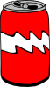
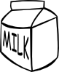
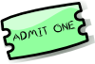
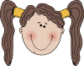
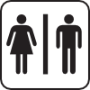
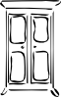
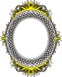
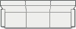

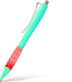


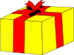
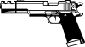
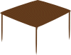

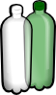
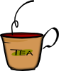
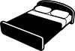
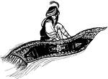
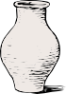
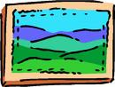

(a cup of) coffee
a clock
a woman
a passport
a (tele)phone
a book
a bottle
a sofa
toilets
a vase
a chair
a girl
a present or gift
sugar
(a can of) coke
a picture or painting
a lamp
water or two bottles of water
New York or the USA
a CD
milk
a dog
a hat
It’s a a cup of tea
a bed
a page
a table
a pen
a mirror
a plane or aeroplane/ airplane
a ticket
a cupboard or wardrobe
a man
a boy
Paris or France
a gun or pistol
a baby
a (flying) carpet
Start
Finish
Answer Key

