**Deutsche Modedesigner**

Karl Lagerfeld Harald Glööckler Wolfgang Joop

Guido Maria Kretschmer Michael Michalsky Jil Sander

Otto Kern Claus-Dietrich Lahrs (CEO) Philipp Plein

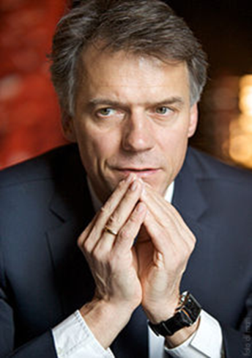 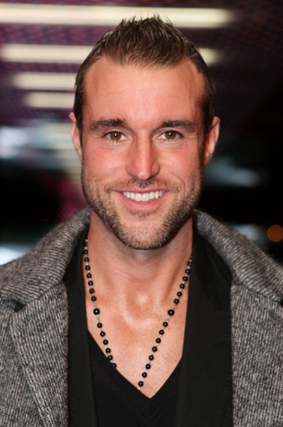 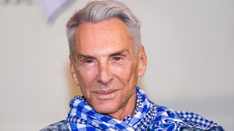

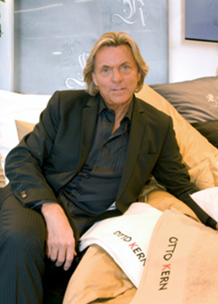 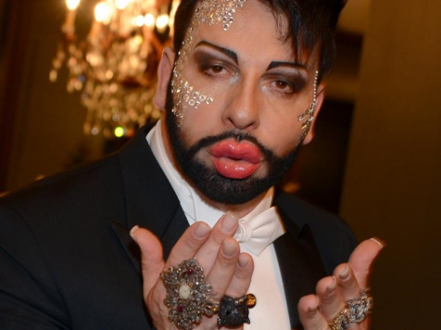 [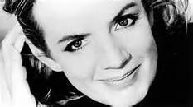](http://www.bing.com/images/search?q=jil+sander&FORM=HDRSC2#view=detail&id=CD6A3D6C5041F1603773610946D48C2F4A5EB371&selectedIndex=199)

