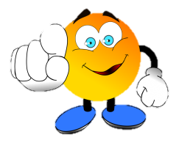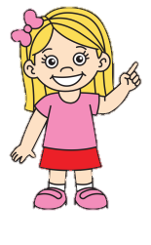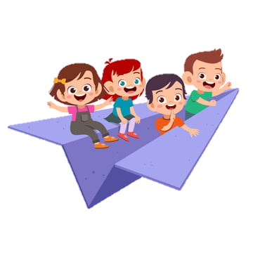

**WE LOVE ENGLISH**

***HOW OLD ARE YOU?***

I AM ____ YEARS OLD.

***Let’s talk about you!***

***What’s your name?***

***-***

***How old are you?***

***-***

***Where are you from?***

***-***

***How are you today? ☺***

***-***

_____________ Clara.

Hello. ________?

**Hello! My name is Matt.** What’s your name?

**Nice to meet you.**

**GREETINGS!**

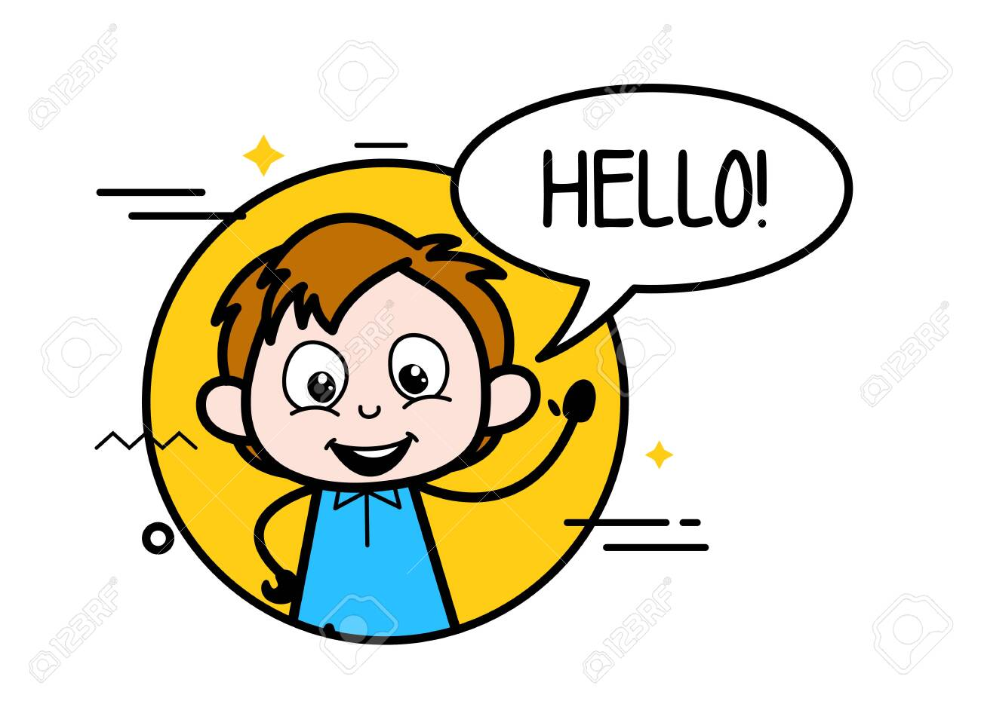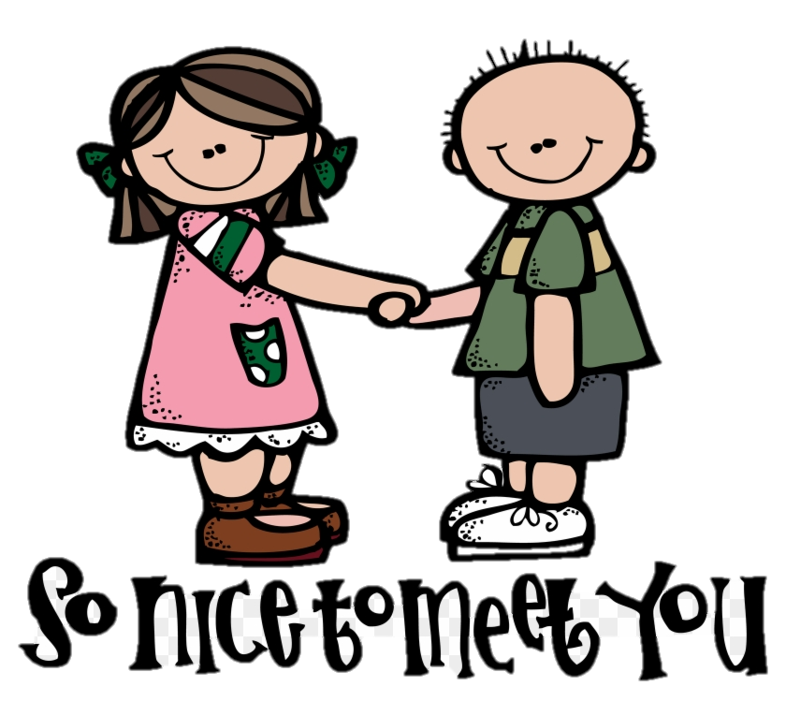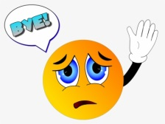

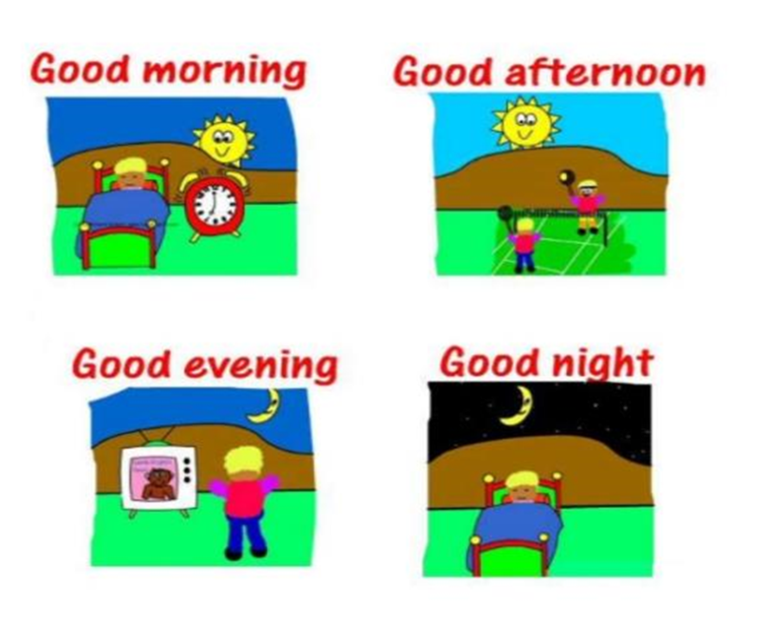

yellowflicker

**NUMBERS (FROM 1 TO 20)**

1=

2=

3=

4=

5=

6=

7=

8=

9=

10=

11=

12=

13=

14=

15=

16=

17=

18=

19=

20=

**BACK TO SCHOOL ☺**