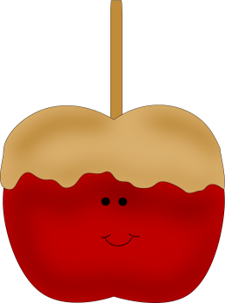
Common Abbreviations:
What are the different abbreviations short for?
A.D. ___________________________
B.C. ___________________________
A.M. ___________________________
P.M. ___________________________
C ___________________________
F ___________________________
DC ___________________________
Mr. ___________________________
Mrs. ___________________________
vs. ___________________________

CLOTHES –and related vocabulary
Clothes (plural): things that you wear
Clothing: clothes in general –used to talk about a particular type of clothes, or to talk about a large quantity of clothes
to wear clothes: to have clothes, shoes, glasses, jewellery on your body
to put on clothes: to put on a piece of clothing
to get dressed: to put on all your clothes
to take off clothes: to remove a piece of clothing that you were wearing
to get undressed: to take off all your clothes
Adjectives to describe people’s clothes
tight (clothes fit your body very closely)
loose (clothes do not fit your body tightly)
baggy (clothes designed to be big and loose)
well-dressed (when you are wearing good quality clothes)
smart (you are dressed in an attractive way)
casual (clothes you wear when you are relaxing)
scruffy (clothes that look dirty and untidy)
match (clothes that look good together; clothes that are a similar colour)
fit (when clothes are the right size)

Use words from the right box:
1. He was wearing summer _____________ even though it was quite cold.
2. I never ________ black. It makes me look too pale.
3. _______ you coat ______ if you are going out.
4. If I ________ my glasses ______ I can hardly see anything.
5. He was wearing ___________ jeans and a T-shirt.
6. You look too _________ to go out to a restaurant.
7. In the weekend I like to wear ____________ clothes.
8. Do the shoes still ________ you?
9. Make sure you have plenty of warm ________________. It can be pretty cold up there.
10. Go and ______ _________. It is nearly time for school.

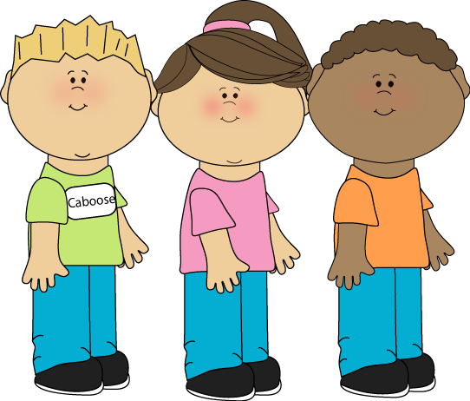

Key:
Abbreviations
Anno Domini
Before Christ
Ante meridiem
Post meridiem
Celcius centigrade
Fahrenheit
District of Columbia
Mister (it is always abbreviated)
Mistress (always abbreviated)
versus
CLOTHES
1. clothes
2. wear
3. Put ……on
4. Take ….. off
5. baggy
6. scruffy
7. casual
8. fit
9. clothing
10. get dressed
www.eegitimim.com

