box.png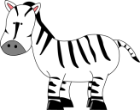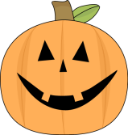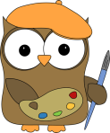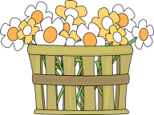

Tell about a thing you would like to learn.

Who is your favorite artist?

Tell about a thing you would like to do next year!

Compare yourself to an animal! What would you be?

Tell about yourself in 10 years’ time!

What is your favorite film?

Talk about a thing you are good at!

Tell about your siblings (a brother or a sister or both)

Who would you like to go to New York with –and why?

Tell about your best teacher ever!

What is your favorite book?

Tell about a person that once helped you?

Tell about something that makes you happy!

Who would you give a basket of flowers?

What is your favorite time of year?

Talk about your favorite holiday in your own country.

What are your dreams?

What would you put in this box and send to a friend?

Give one of the players a compliment!

If you have a girl – what would you name her?

What is your pair of favorite shoes?

What is the best time of day according to you?

Talk about your favorite clothes.

Talk about your favorite holiday abroad.

Tell about an important person in your life.

Tell about your parents.

Tell about a thing that is very dear to you.

You get an extra throw!

Tell about your best friend!

Tell about something you are thankful for!

Tell about a goal you have for your life!

What is your favorite dish?

What did your bedroom look like when you were a kid?