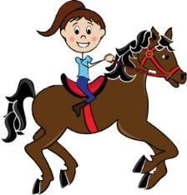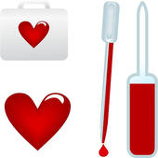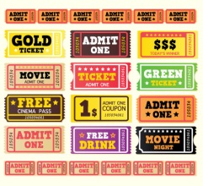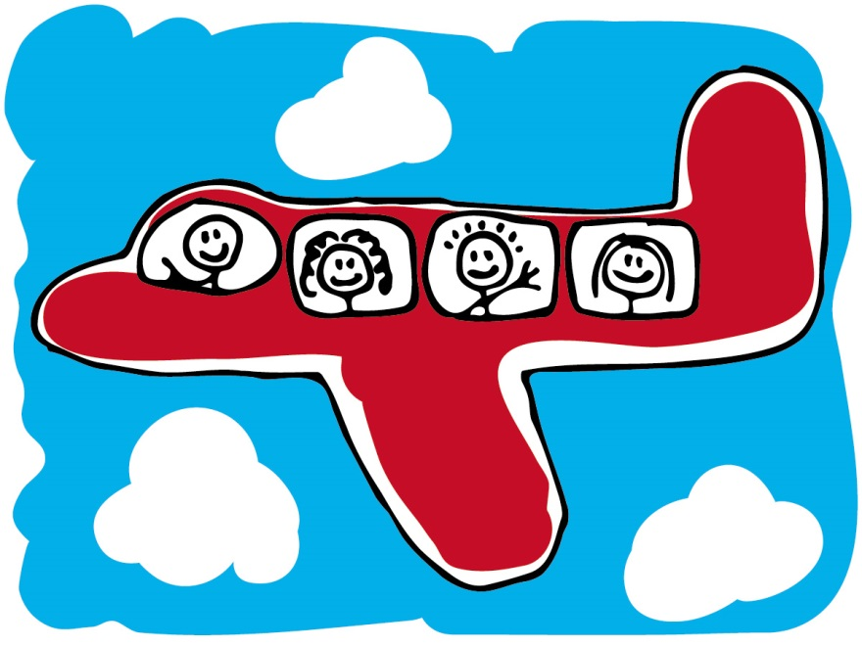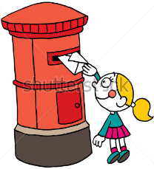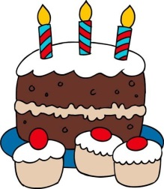

**They / pay / 60 $ for the ticket**

**the wind / damage / the trees**

**The weather / be / cold**

**Go Back**

**3**

**they / fly / in a plane**

**the child / ride / a horse**

**2**

**Move Ahead**

**Make Your Own**

**Sentence**

**they / eat / all the food**

**you / have / a blood test**

**Grandpa Sam / finish / his breakfast**

**they / loose / their keys**

**the boy / see / a tiger**

**my mother / make / a birthday cake**

**he / break /**

**his leg**

**Go Back**

**4**

**I / walk /**

**a long way**

**he / climb /**

**a tree**

**Move ahead**

**2**

**I / work / there for 2 years**

**she / post / the letter**

**START!**