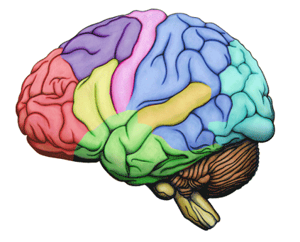

When you sit for longer than 15 – 17 minutes, blood pools in your hamstrings, the large muscles in the back of your leg. That pulls needed oxygen and glucose from the brain and when that happens the body produces melatonin and your brain is essentially telling your body, “You can go to sleep because no movement has occurred.” Your concentration goes down!

Here are a few brain breakers I use in my classroom:

**“Last letter…first letter”**

Students take turns saying a word in English. The next student in line must listen carefully and say a word that begins with the letter the word that has just been said ended in! This goes on till everybody has said a word.

Variation: Students, who say a wrong word, are out and must sit down. The others continue.

**Clapping Drill** (Use is as a transition drill)

Teacher claps his/her hands in this rhythm:

1 – 2

1 – 2 – 3

1 – 2 – 3 – 4 ……..and students join in clapping 1 – 2 !

Right after the clapping ends there is silent and it is a good way to move on with a new task.

**The Rat Trap**

Students stand in a circle. They hold their left palm facing up and flat to the left below shoulder level. Students place the point of their right index finger in the palm of the person standing on the right. Then the teacher starts telling a story about a rat. Every time the word rat is said the students try to grab the finger in their left hand, and at the same time remove their right index finger before it gets caught.

**Shoot Out**

Students pair up. They stand with their hands on the back. They count to three: “1, 2, 3!” and then they put their hands in front of their bodies. Now they have to count the number of fingers (on all four hands) and shout the number out loud. If it is correct, the person wins the round.

Variation: Instead of addition, you can subtract, divide or multiply.

**Thumb and Index Finger Drill**

Place one hand oout in front of you, with the thumb up and the other hand in front of you with the index finger out. When the teacher says: “Switch”, switch the fingers on your hands, the thumb-up hand to the pointer and vice versa. (It gets easier with practice!)