- Can you swim?
- Yes, I can.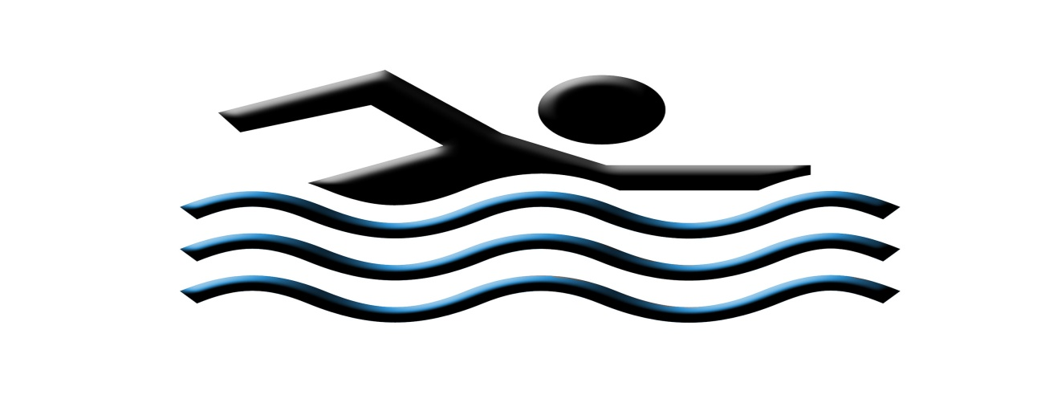
- Can you drive?
- No, I can’t.
