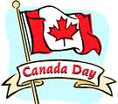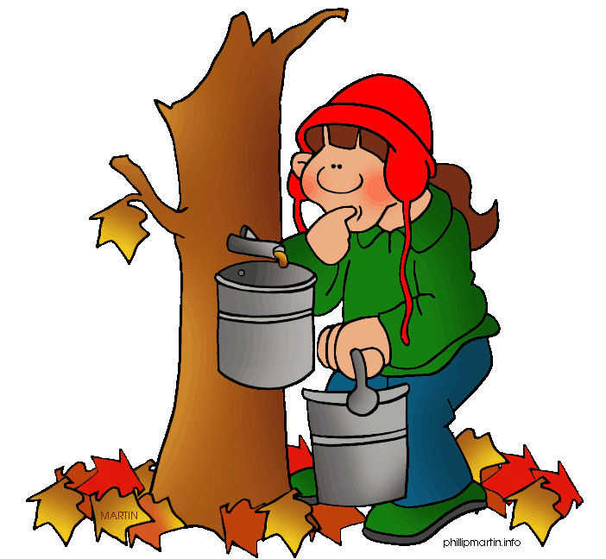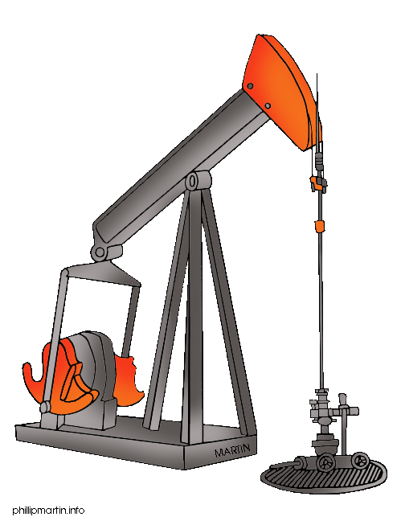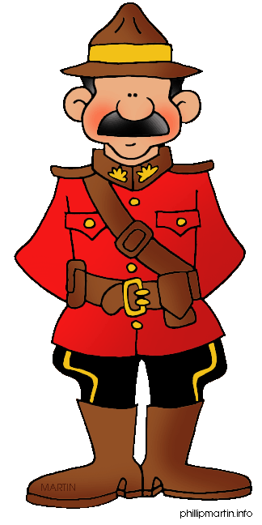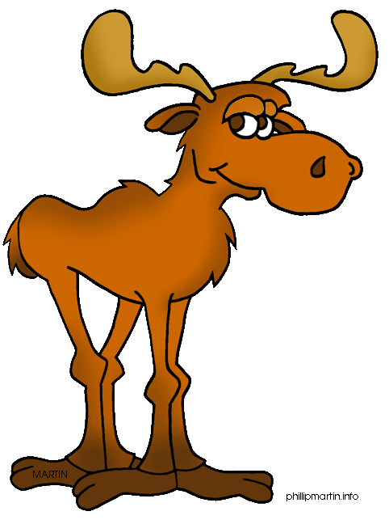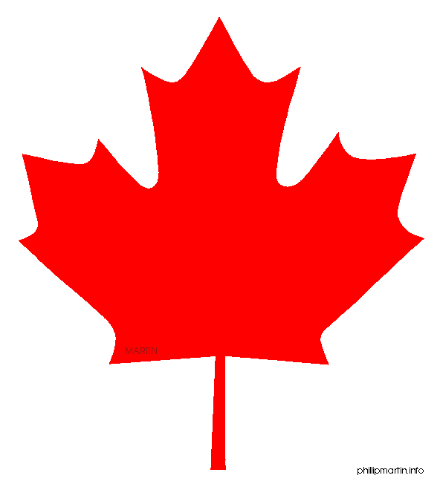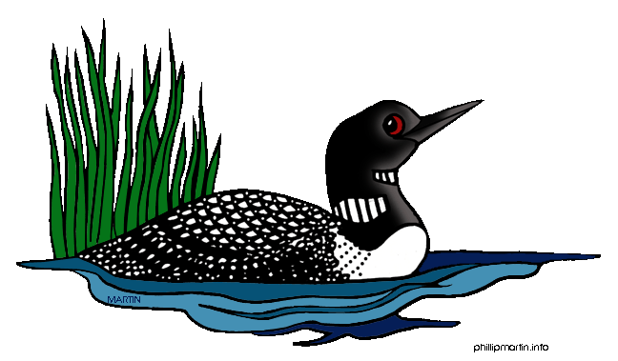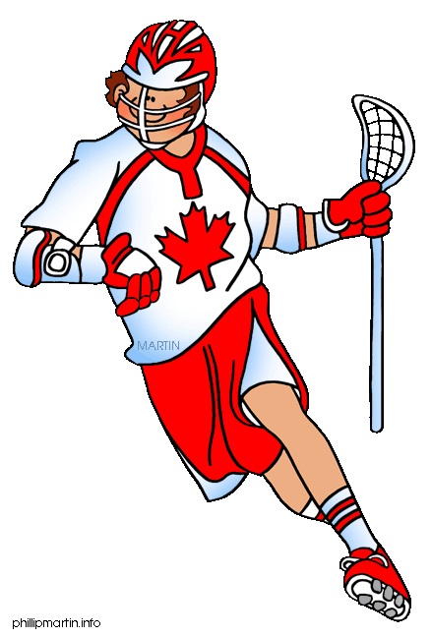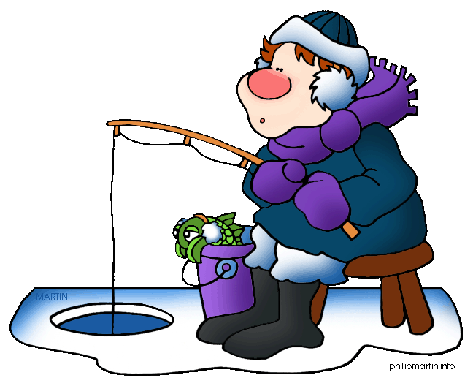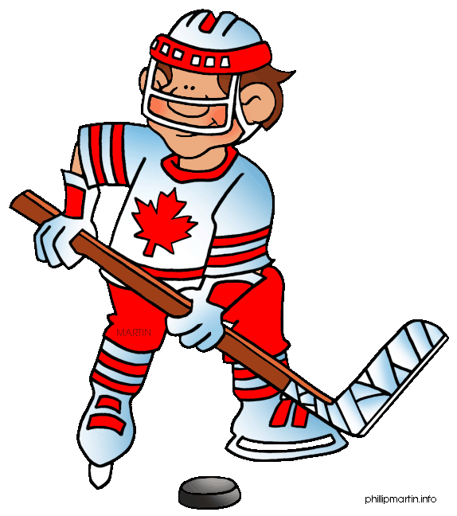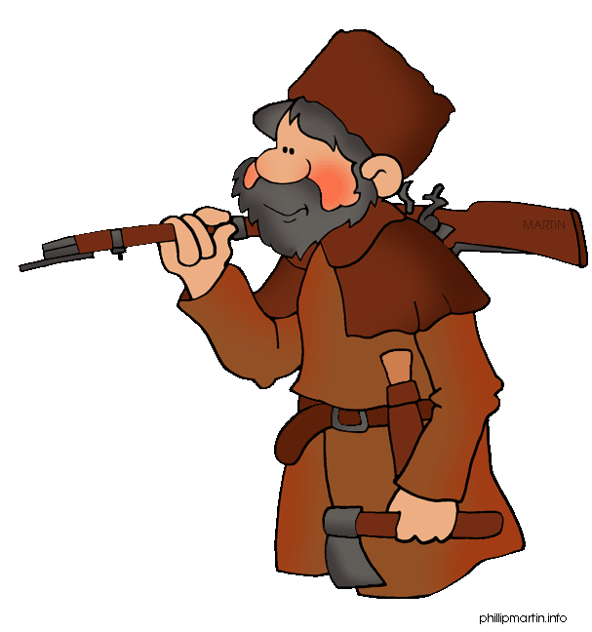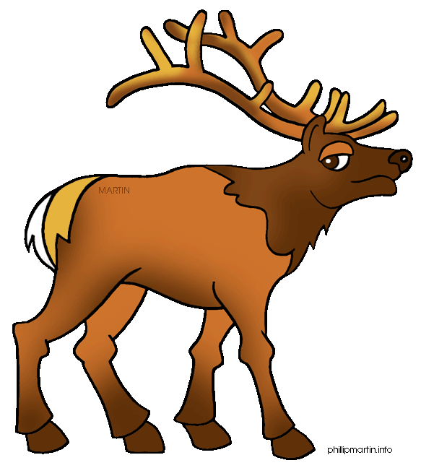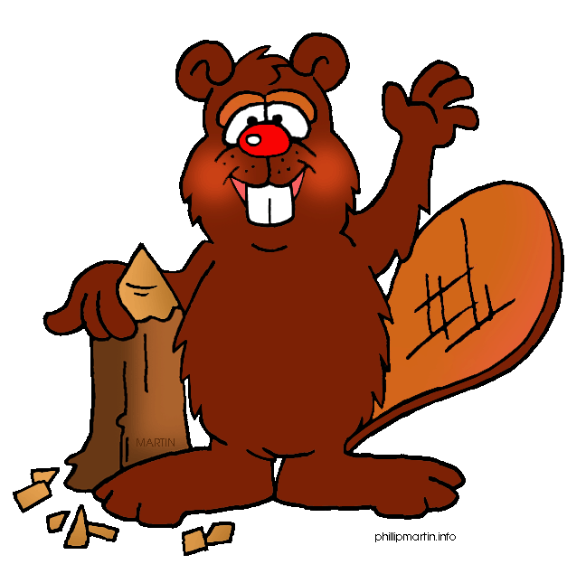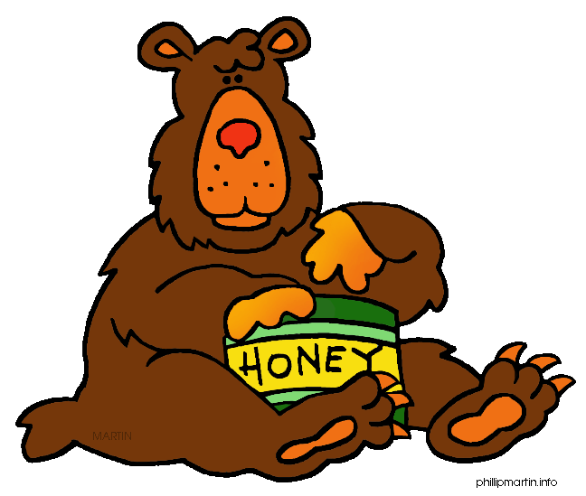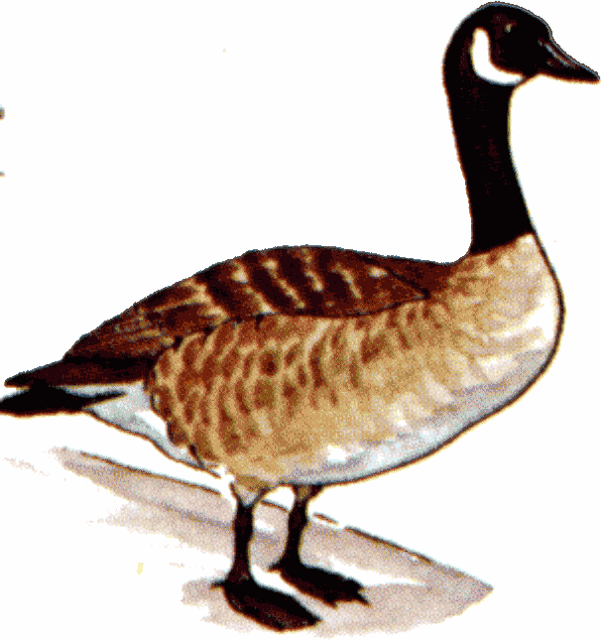

How many provinces are there in Canada?

What is a **toonie**?

What is a **loonie**?

**What is the capital of Canada?**

What is the name of the province that borders to the Atlantic Ocean?

When is Canada Day celebrated?

What is the currency of Canada?

What is the name of the province that borders to the Pacific Ocean?

How many official languages do they have in Canada?

Mention three famous people from Canada.

What does the word Canada (Kanata) mean?

What country borders to the south of Canada?

Who is the Canadian head of state?

How does the Canadian motto go? “From………..”.

How many provinces and territories has Canada got?

Mention two kinds of bears native to Canada!

You get an extra throw!

What is she getting from the tree?

Mention three sports typical for Canada.

Mention 4 Canadian cities!