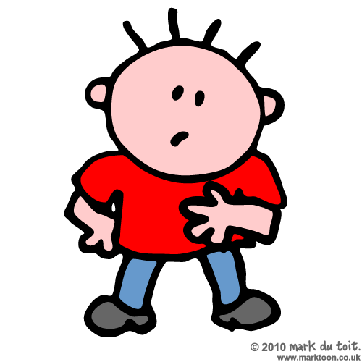
Fill in the missing letters (vowels a-e-i-o-u-y):
12. D __ C __ M B __ R

1. __ __ S T __ R
2. C H R __ S T M __ S
3. N __ W __ __ __ R

- C __ R
- T __ X __
- B __ K __
- __ __ R P L __ N __
- B __ S
- M __ T __ R B __ K __
- S C __ __ T __ R
- B __ __ T
- S H __ P
- F __ R R __

- M __ L K
- B R __ __ D
- B __ T T __ R
- __ G G S
- C H __ __ S __
- J __ __ C __
- J __ M
- N __ T S
- M __ __ T
- P __ Z Z __
- T __ __
- C __ F F __ __

- B __ R D
- C __ T
- D __ G
- S N __ K __
- G __ R __ F F __
- __ L __ P H __ N T
- C __ M __ L
- R H __ N __
- H __ R S __
- C __ W
- S H __ __ P
- H __ N
- C __ C K
- D __ N K __ __
- B __ __ R
- W __ L F

- J __ N __ __ R __
- F __ B R __ __ R __
- M __ R C H
- __ P R __ L
- M __ __
- J __ N __
- J __ L __
- __ __ G __ S T
- S __ P T __ M B __ R
- __ C T __ B __ R
- N __ V __ M B __ R

- B __ D __
- L __ G
- __ R M
- H __ N D
- F __ __ T
- T __ __
- __ N K L __
- K N __ __
- __ __ __
- __ __ R
- S T __ M __ C H
- B __ C K
- H __ __ D
- H __ __ R
- F __ N G __ R
- N __ S __

- J __ __ N S
- T – S H __ R T
- S H __ __ S
- S H __ R T S
- S K __ R T
- S __ C K S
- H __ __ D __ __
- D R __ S S
- J __ C K __ T
- C __ __ T
- G L __ V __ S

