False

True

Look at the picture and tick your answer!

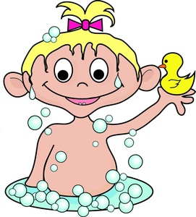

1. The baby is a girl.

2. The baby girl is not happy.

3. The girl is having a bubble bath.

4. There is a duck in her left hand.

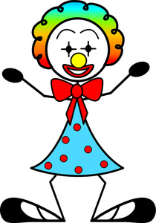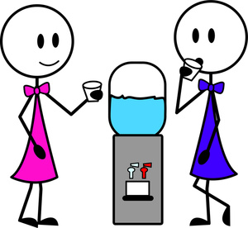

**homework@live.dk**

4.You can see two taps.

3. They are drinking water.

2. They wear jeans.

1. There are two girls in the picture.

5. The shoes are big.

4. The clown is smiling.

3. The dress has got seven dots.

2. The clown has got two ears.

1. The clown is a boy.