What is the best thing to give your parents for Christmas?

!

Find these words in the puzzle. The letters left make up the answer of the joke.

To find the answer you must write the letters not ”used” from left to right.

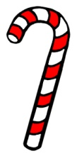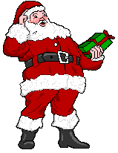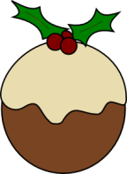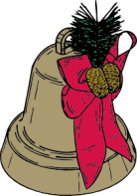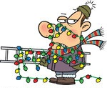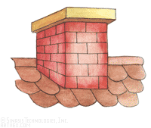

O

X

E

R

C

U

X

O

W

I

A

W

Y

N

C

L

Y

L

C

A

W

U

N

E

R

G

K

M

K

E

M

D

T

T

N

A

M

A

G

R

A

W

U

O

I

I

R

Y

N

R

N

N

W

I

G

H

T

Y

R

H

N

S

A

C

K

B

V

C

C

A

N

D

Y

C

A

N

E

E

E

A

E

V

E

F

O

T

S

I

L

C

G

S

C

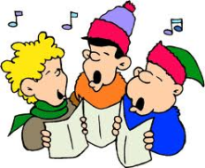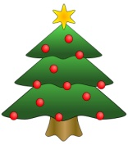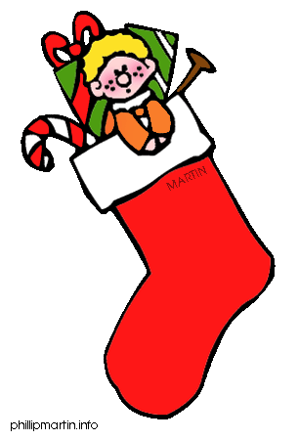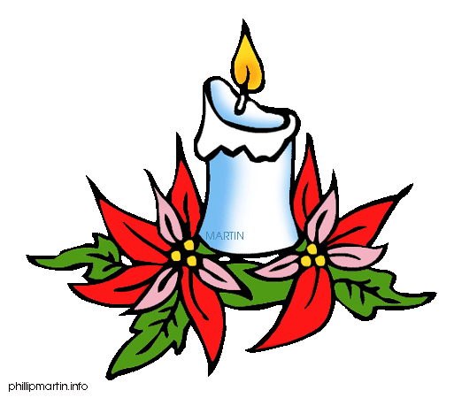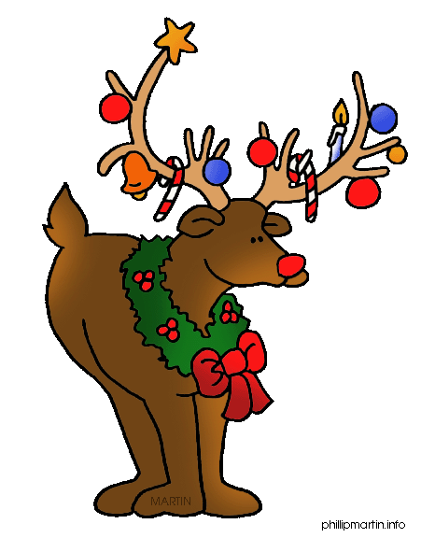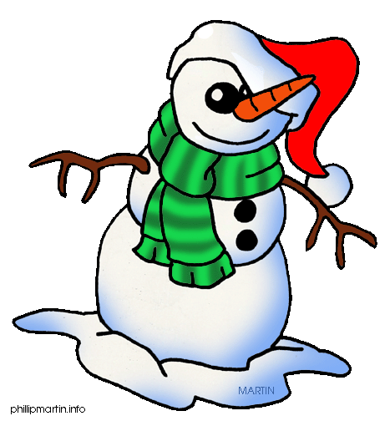

Z

R

U

F

T

S

E

J

L

C

K

F

N

Z

J

E

B

U

L

G

N

A

E

D

O

X

M

M

P

D

L

F

P

J

C

M

A

S

N

L

E

U

O

R

G

G

I

I

H

M

N

I

T

S

A

S

Z

U

A

B

L

I

R

S

O

S

A

V

U

K

C

A

N

L

E

S

L

K

R

T

Y

H

D

L

D

F

T

S

N

P

U

F

P

H

U

O

I

D

D

T

M

E