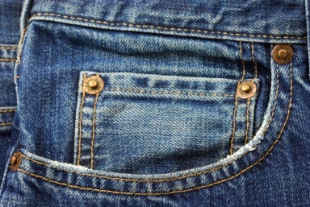

1. Pants usually made of blue denim.

2. A piece of clothing for a girl that has a top part and a skirt that hangs down the legs.

3. A shoe with a bottom part that is held in place with straps around the foot and the ankle.

4. A piece of clothing in two parts worn by girls for swimming or tanning.

5. This accessory is worn by men around the neck when they wear a shirt.

6. Covering for the hands that has separate parts for each finger.

7. It has short sleeves, no collar, and is usually made of cotton.

8. A warm usually knitted piece of clothing for the upper part of the body.

9. A shirt for women and girls.

10. A small soft hat often with a visor.

11. An outer piece of clothing –usually long – worn to keep you warm and dry.

12. Shoes with rubber soles designed for sports.

13. A jacket and pants made of the same material.

14. A piece of clothing worn to support the breasts.

15. A girl’s underwear.

16. A band of leather worn around the waist.

17. Clothing that people wear in bed.

18. A piece of clothing (worn by women) that usually hangs from the waist down.

19. A piece of clothing that covers your body from the waist to the ankle and has a separate part for each leg.

20. A usually short and light coat.

21. A sleeveless undershirt.

22. Loose rubber sandals.

23. A long piece of clothing worn on your shoulders, around your neck, or over your head.

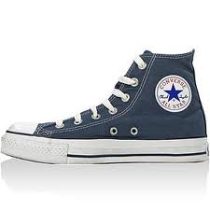

A



1. Pants usually made of blue denim.

2. A piece of clothing for a girl that has a top part and a skirt that hangs down the legs.

3. A shoe with a bottom part that is held in place with straps around the foot and the ankle.

4. A piece of clothing in two parts worn by girls for swimming or tanning.

5. This accessory is worn by men around the neck when they wear a shirt.

6. Covering for the hands that has separate parts for each finger.

7. It has short sleeves, no collar, and is usually made of cotton.

8. A warm usually knitted piece of clothing for the upper part of the body.

9. A shirt for women and girls.

10. A small soft hat often with a visor.

11. An outer piece of clothing –usually long – worn to keep you warm and dry.

12. Shoes with rubber soles designed for sports.

13. A jacket and pants made of the same material.

14. A piece of clothing worn to support the breasts.

15. A girl’s underwear.

16. A band of leather worn around the waist.

17. Clothing that people wear in bed.

18. A piece of clothing (worn by women) that usually hangs from the waist down.

19. A piece of clothing that covers your body from the waist to the ankle and has a separate part for each leg.

20. A usually short and light coat.

21. A sleeveless undershirt.

22. Loose rubber sandals.

23. A long piece of clothing worn on your shoulders, around your neck, or over your head.

F

S

K

I

R

T

L

C

I

E

S

U

O

L

B

D



F

R

A

C

S

P

P

S

F

L

O

V

E

T

J

A

C

K

E

S

R

E

S

U

O

R

T

S

N

A

R

B

E

S

A

M

A

J

A

P

T

I

U

S

W

E

R

E

A

T

L

B

P

C

S

E

I

T

N

A

P

R

E

N

I

A

R

T

A

I

N

I

K

B

A

T

R

I

H

S

S

E

V

O

G

T

I

S

L

D

N

A

A

S

S

E

R