Why did Tigger look inside the toilet?
Clues
- A male cow!
- What is 1609 metres? A ….
- Something kids like.
- A vegetable; orange and green.
- A small rodent.
- What a bride wears.
- A nation with fifty states.
- A whitish liquid.
- A person who has great goodness and kindness.
- A period of rest from school.
- Move your legs very fast.
- Number that follows ten.
- Opposite of he.
- A weak person.
- A historic building.
- A human-like animal.
- Where kids are taught.
- In the sky at night.
- Not young.
- What you get from mixing red and yellow.
- Before two.
- Odd, peculiar.
- A building used for religious services.
- Capital city of France.
- A weekday.
- A strong feeling of liking and caring about another thing.

7

2
5

4

1

3

6

13
12

14

9

19

17
8

Your answer:

18

16

10

15

20

22

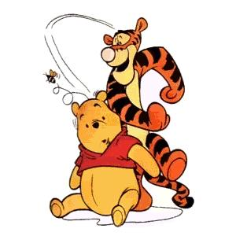
21
11

24

26
25

23

KEY:
- BULL
- MILE
- CANDY
- CARROT
- MOUSE
- VEIL
- USA
- MILK
- ANGEL
- VACATION
- RUN
- ELEVEN
- SHE
- WIMP
- LANDMARK
- MONKEY
- SCHOOL
- MOON
- OLD
- ORANGE
- ONE
- FUNNY
- CHURCH
- PARIS
- MONDAY
- LOVE
ANSWER: He was looking for Pooh!

