stool

fall

cloth

place

land

fish

standing

self

stream

sauce

print

work

smith

keeping

room

sweet

line

power

way

kerchief

bee-

bed-

gold-

finger-

main-

night-

star-

table-

air-

toad-

bitter-

father-

net-

hand-

high-

horse-

market-

out-

my-

apple-

-

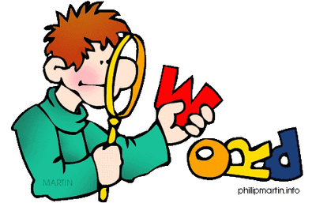

stool

fall

cloth

place

land

fish

standing

self

stream

sauce

print

work

smith

keeping

room

sweet

line

power

way

kerchief

bee-

bed-

gold-

finger-

main-

night-

star-

table-

air-

toad-

bitter-

father-

net-

hand-

high-

horse-

market-

out-

my-

apple-

-

G

N

I

D

N

A

T

S

S

E

F

L

T

L

O

P

R

L

T

R

R

E

F

I

S

H

O

I

E

C

P

L

A

T

O

N

M

O

S

M

I

H

T

K

R

W

O

W

L

W

E

N

I

L

E

L

S

A

U

C

E

A

Y

T

G

K

E

E

P

I

N

O

D



W

F

E

I

H

C

R

K

E

R