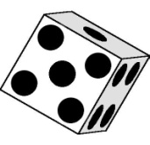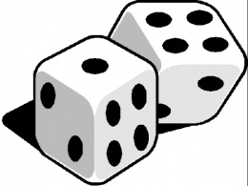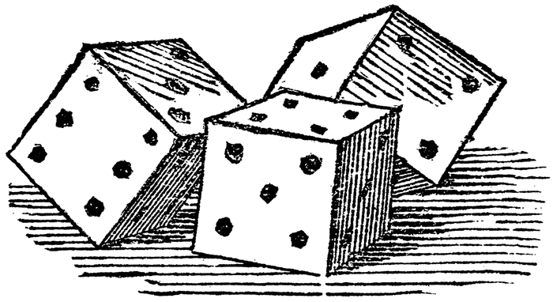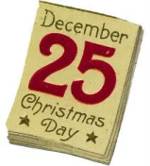

22

N

E

V

E

L

21

T

H

R

E

S

I

X

T

Y

20

19

R

F

O

18

T

H

I

R

N

E

E

E

V

F

17

13

S

E

V

N

14

T

W

E

N

T

Y

-

F

I

V

E

V

L

15

W

E

16

T

H

G

I

D

E

R

D

N

U

H

5

X

S

7

12

E

N

I

N

E

E

T

X

I

S

11

8

F

I

V

10

E

N

6

E

V

O

3

L

I

9

E

N

O

-

Y

T

N

E

W

4

T

W

O

R

E

Z

2

N

O

U

G

H

N

E

T

1

1. Number of the address of Downing Street home to the British Prime Minister .

2. Two different names for the cipher 0.

3. How is 0 said in the soccer score 1-0?

4. What is the smallest prime number?

5. 12 + 3 – 4 + 5 + 67 + 8 + 9 = ?

6. What is the score seen with “tennis glasses” 6-0?

7. How many “zeroes” are there in a million?

8. How many legs or arms are most usually on a starfish?

9. How many dots are on a (standard 1-6) die?

10. Number of the highway running from San Francisco to Los Angeles!

11. How many pieces does a player begin with in a game of chess?

12. If you are blissfully happy, you are on cloud ……?

13. Number of dwarfs in the story of Snowwhite!

14. Christmas is celebrated on what day in December?

15. Number of months!

16. Number of years the American president can stay in office!

17. Number of eyes, noses and ears on a human being!

18. Considered an unlucky number in many countries.

19. Number following three.

20. Seconds in an hour.

21. ……Blind Mice –See How They Run.

22. Number of players in a cricket team.