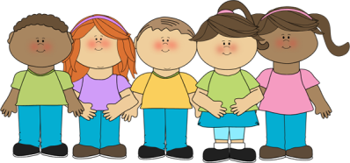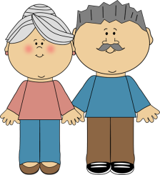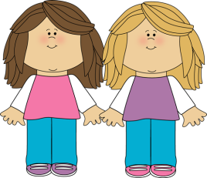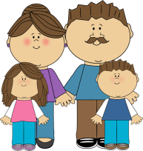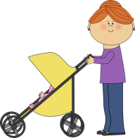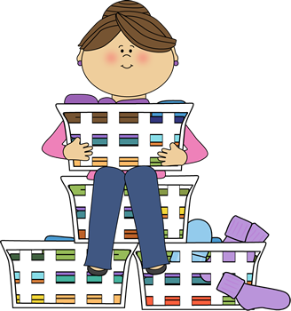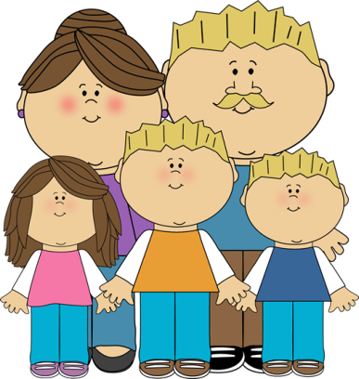

-

-

1. A female parent.

2. A married man.

3. A brother or sister.

4. A girl who has the same parents as you.

5. Two babies born at the same time.

6. The brother of your father or mother.

7. A member of your family.

8. A married woman.

9. Someone’s husband or wife.

10. A young person.

11. A son of your brother or sister.

12. A child of your aunt and uncle.

13. The brother of your husband or wife.

14. A man who is not married.

15. The people in a family or other group that are living together.

16. A woman who has just married or is about to marry.

17. A man who has just married or is about to marry.

18. Someone who is married: a husband or a wife.

19. A former husband or wife.

20. An unmarried woman.

21. A parent of your father or mother.

22. A daughter of your brother or sister.

23. A family that includes not only parents and children but also other relatives.

24. An old-fashioned word for a person’s relatives.



K

I

D

E

D

N

E

T

X

E

S

U

O

P

S

N

I

E

E

G

R

A

N

D

P

A

R

E

N

T

M

SI

S

X

R

L

E

H

C

A

B

M

O

R

G

B

R

I

E

D

L

O

H

E

S

U

O

H

O

W

A

L

-

N

I

-

R

E

H

T

O

R

B

N

I

S

U

C

E

V

I

T

A

L

R

W

E

H

N

E

R

E

N

T

P

A

D

L

I

H

W

I

F

E

U

N

C

L

S

N

I

W

R

E

T

S

S

G

N

I

L

B

I

D

N

A

B

S

U

R

E

H

T

O

M

1. A female parent.

2. A married man.

3. A brother or sister.

4. A girl who has the same parents as you.

5. Two babies born at the same time.

6. The brother of your father or mother.

7. A member of your family.

8. A married woman.

9. Someone’s husband or wife.

10. A young person.

11. A son of your brother or sister.

12. A child of your aunt and uncle.

13. The brother of your husband or wife.

14. A man who is not married.

15. The people in a family or other group that are living together.

16. A woman who has just married or is about to marry.

17. A man who has just married or is about to marry.

18. Someone who is married: a husband or a wife.

19. A former husband or wife.

20. An unmarried woman.

21. A parent of your father or mother.

22. A daughter of your brother or sister.

23. A family that includes not only parents and children but also other relatives.

24. An old-fashioned word for a person’s relatives.