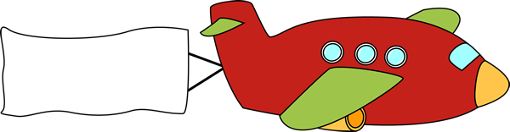

28

29

21

10

5

4

23

27

19

22

16

14

17

2

1

25

15

24

18

12

8

7

3

20

13

26

11

9

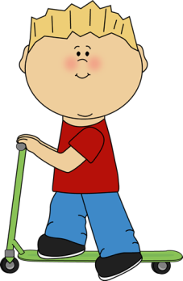

*Across:*

1. A machine that has wings and an engine and that flies through the air.

2. Time when the sun goes below the horizon.

3. To say something again.

9. Abbreviation of Alaska.

11. A religious group settled in America whose members continue to live a traditional way on farms.

13. Past tense of *ask*.

15. A severe snowstorm.

17. To make a deep sound because of pain.

18. A form of “to be”.

21. The ninth letter of the alphabet.

24. A long poem that tells the story of a hero’s adventures.

26. A picture or chart that shows the rivers, mountains, cities, streets etc. in a particular area.

27. A form of “to be”.

29. Even though.

*Down:*

1. European country.

4. A downhill ski trail.

5. A school subject.

7. A deer.

8. Short form of *place*.

10. Language spoken in England.

12. You hand is attached to it!

13. Her second book is twice as long …… her first one.

14. The possibility that something bad or unpleasant will happen.

16. British for Australia.

19. Not able to think or act normally because you have been surprised or injured etc.

20. An interjection especially used in Canada to urge someone to agree.

22. A short period of sleep especially during the day.

23. A person inclined to wild sports.

25. Abbreviation for *Rhode Island*.

28. The fourth note of a musical scale.





28

F

29

I

21

I

10

E

N

5

A

L

4

P

R

I

23

M

27

A

19

D

N

R

I

A

U

A

22

N

A

16

O

14

R

17

G

T

E

S

N

U

2

S

1

A

D

25

R

A

Z

Z

I

L

15

B

T

T

C

I

P

24

E

S

18

I

T

12

A

E

8

P

7

E

3

R

A

D

20

E

K

S

13

A

R

L

L

I

P

A

26

M

H

H

S

I

M

11

A

K

9

A



*Across:*

1. A machine that has wings and an engine and that flies through the air.

2. Time when the sun goes below the horizon.

3. To say something again.

9. Abbreviation of Alaska.

11. A religious group settled in America whose members continue to live a traditional way on farms.

13. Past tense of *ask*.

15. A severe snowstorm.

17. To make a deep sound because of pain.

18. A form of “to be”.

21. The ninth letter of the alphabet.

24. A long poem that tells the story of a hero’s adventures.

26. A picture or chart that shows the rivers, mountains, cities, streets etc. in a particular area.

27. A form of “to be”.

29. Even though.

*Down:*

1. European country.

4. A downhill ski trail.

5. A school subject.

7. A deer.

8. Short form of *place*.

10. Language spoken in England.

12. You hand is attached to it!

13. Her second book is twice as long …… her first one.

14. The possibility that something bad or unpleasant will happen.

16. British for Australia.

19. Not able to think or act normally because you have been surprised or injured etc.

20. An interjection especially used in Canada to urge someone to agree.

22. A short period of sleep especially during the day.

23. A person inclined to wild sports.

25. Abbreviation for *Rhode Island*.

28. The fourth note of a musical scale.

