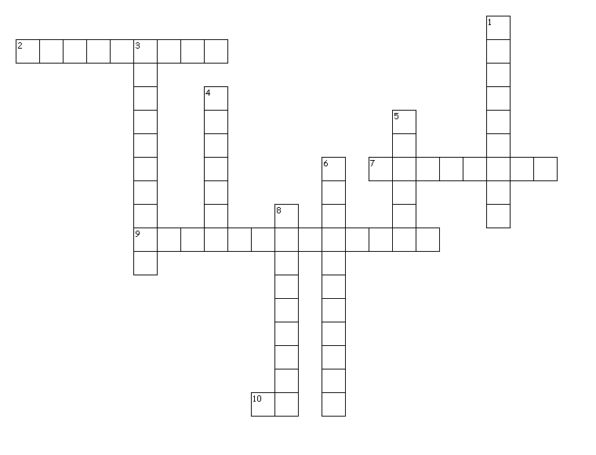

**Down**

1. The business of trying to sell a product by deciding which type of people are likely to buy it and making it attractive and interesting to them.

3. An advertisement on television or radio

4. - To try to make people buy a new product, to see a new film.

5. A short clever phrase used in advertisements.

6. The business of persuading people to buy things, using pictures, words, songs etc on TV and radio,large public notices and newspapers and magazines

8. A large flat board in a public place, where large printed advertisements are shown.

**Across**

2. The business of making sure that people know about a new product, a new film, a famous person etc.

7. British word for a large flat board in public place where large printed advertisements are shown.

9. A large public notice or a picture with words in a newspaper that is designed to persuade people to buy something.

10. Informal word for advertisement