|  |  |  |  |  |  |  |  |  |  |  |  |  |
| --- | --- | --- | --- | --- | --- | --- | --- | --- | --- | --- | --- | --- |
|  | **14** |  |  | **2** |  |  | **13** |  | **16** |  |  |  |
|  |  | **1** |  |  |  | **12** |  |  |  |  |  |  |
|  |  |  |  |  |  |  |  |  |  | **18** |  |  |
| **3** |  |  |  |  |  | **15** |  |  | **4** |  |  |  |
|  |  |  |  |  |  |  | **6** |  |  |  |  |  |
|  |  | **7** | **5** |  |  |  |  |  |  |  |  |  |
|  |  |  |  |  |  |  |  |  |  |  |  |  |
|  | **8** |  |  |  |  | **9** |  |  | **10** |  |  |  |
|  |  |  |  | **11** |  |  | **13** |  |  |  |  |  |
|  | **10** |  |  |  |  |  |  | **12** |  |  |  |  |
|  |  |  |  |  |  |  | **15** |  |  |  |  |  |
| **14** |  |  |  | **11** |  |  |  |  |  | **17** |  |  |

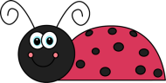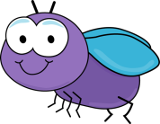



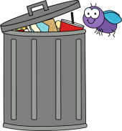

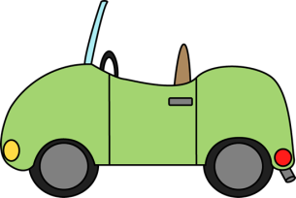

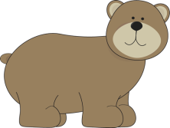

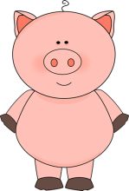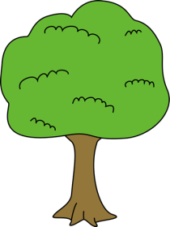

Down

2. A red and black insect.

3. What the boy has in the wheelbarrow.

4. This is where garbage goes.

6. A vehicle.

7. There are __________ in the basket.

9. An animal from North America.

10. A tool you use to chop wood.

11. How ______ you ______?

12. Not you but _____!

13. A pet.

14. I have – you have – he _________.

15. I am – you are – she _________.

16. Look at the picture ________ the wall.

17. Something you can fly.

18. Ready, ___________, go!

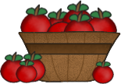

Across

1. A small insect.

3. You find it in the playground.

4. It is very hot!

5. A small cake with chocolate chips.

8. The animal you get bacon from.

10. A thing you can climb.

11. It grows outside.

12. It brings good luck.

13. A big bird.

14. He is not ______ fast ______ her.

15. Opposite of women.

16. The infinitive of is and are.

17. Opposite of out!

