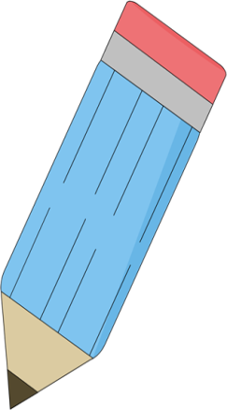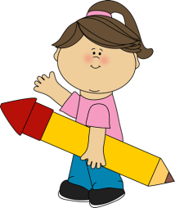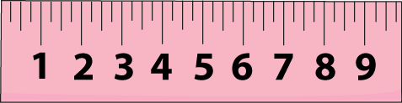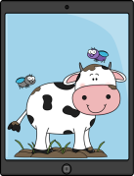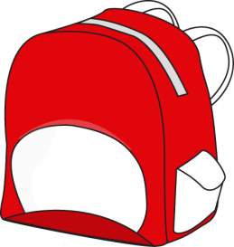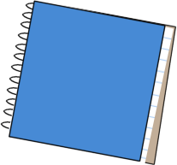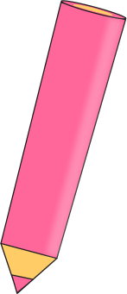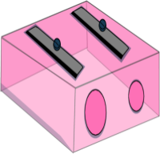

1. A cover for holding together sheets of paper.

2. Work a student is given to do at home.

3. A person that teaches something.

4. A person who attends school, college or university.

5. A room or building that has equipment for sports activities.

6. A special pen with brightly coloured ink that you can see through.

7. A small computer that is designed to be easily carried.

8. A writing instrument that uses ink.

9. A tool or machine that makes something sharp.

10. A picture or chart that shows the rivers, mountains, streets etc.

11. A piece of furniture that is like a table.

12. A set of questions or problems that are designed to measure a person’s knowledge.

13. In this subject you study past events.

14. A set of printed sheets of paper that are held together inside a cover.

15. The act of reading something.

16. A subject in which you work with numbers.

17. A type of soft rock you can write with.

18. A number or letter that indicates how a student performed in a class or a test.

19. A book with blank pages that is used for writing notes.

20. A straight piece of plastic, wood, or metal that has marks on it to show units of length and that is used to measure things.

21. A large picture put on walls for decoration.

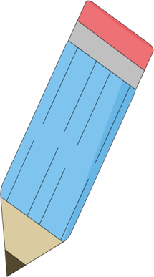

R

E

T

S

O

P

1. A cover for holding together sheets of paper.

2. Work a student is given to do at home.

3. A person that teaches something.

4. A person who attends school, college or university.

5. A room or building that has equipment for sports activities.

6. A special pen with brightly coloured ink that you can see through.

7. A small computer that is designed to be easily carried.

8. A writing instrument that uses ink.

9. A tool or machine that makes something sharp.

10. A picture or chart that shows the rivers, mountains, streets etc.

11. A piece of furniture that is like a table.

12. A set of questions or problems that are designed to measure a person’s knowledge.

13. In this subject you study past events.

14. A set of printed sheets of paper that are held together inside a cover.

15. The act of reading something.

16. A subject in which you work with numbers.

17. A type of soft rock you can write with.

18. A number or letter that indicates how a student performed in a class or a test.

19. A book with blank pages that is used for writing notes.

20. A straight piece of plastic, wood, or metal that has marks on it to show units of length and that is used to measure things.

21. A large picture put on walls for decoration.

R

U

L

E

R

N

O

T

K

O

O

B

G

R

E

D

K

L

A

H

C

T

S

E

H

T

A

R

E

A

G

N

I

B

O

O

Y

R

O

T

S

I

H

D

E

K

M

A

R

E

N

E

P

R

A

H

S

N

P

G

Y

M

M

U

I

S

N

L

A

P

P

O

R

E

T

H

G

I

L

H

G

I

S

T

U

D

E

T

R

E

H

C

A

T

H

O

M

E

W

O

K

R

E

D

N

I

B